IEEE 2026 SoutheastCon Hardware Competition Ruleset

Published August 15, 2025



**Table of Contents**

1 Introduction 6

1.1 Objective 6

1.1.1 Locate and rescue the Astro-Ducks 6

1.1.2 Establish communication with Earth 6

1.1.3 Restore power to the antennas 6

1.1.4 Communicate the antennas’ LED color to Earth 7

1.1.5 Plant your school’s flag 7

1.2 General Vehicle Requirements 7

1.3 Additional Vehicle Specifications 7

2 Board Design 8

2.1 Board Construction 9

2.1.1 Board General Construction 9

2.1.1.1 Board Base 10

2.1.1.2 Border Walls 10

2.1.1.3 Legs 10

2.1.1.4 Stabilizing Joint 10

2.1.1.5 Start LED bar 10

2.1.1.6 Earth Arm Construction 11

2.1.2 Crater Construction 11

2.1.3 Crater Part Description 12

2.1.3.1 Crater Upper Rim 12

2.1.3.2 Crater Lower Rim 12

2.1.3.3 Crater Flat Area V1 12

2.1.3.4 Crater Flat Area V2 13

2.1.3.5 Crater Line 13

2.2 Playing Field Areas 14

2.2.1 Area #1 14

2.2.2 Area #2 14

2.2.3 Area #3 14

2.2.4 Area #4 15

2.2.5 Astro-Duck Placement 15

2.2.6 Painted Zones 15

2.3 Antenna Construction 16

2.3.1 Antenna #1 18

2.3.2 Antenna #2 19

2.3.3 Antenna #3 20

2.3.4 Antenna #4 21

2.4 Earth Construction 22

2.4.1 Basic Construction 22

2.4.2 3D Part Description 24

3 Rules of Play 25

3.1 Hardware Competition Rounds 25

3.1.1 Qualifying 25

3.1.2 Semifinals and Finals 25

3.2 Open teams 26

4 Calculating Scores 27

4.1 Rewards 27

4.2 Penalties 28

4.3 Tiebreakers 28

5 Logistics 28

5.1 General Safety 29

5.2 Team check in 29

5.3 Hardware Room 29

5.4 Practice Boards 29

5.5 Sequestered Area 29

5.6 Pre-staging 29

5.7 Setting up for a match 29

5.8 Conducting the match 29

5.9 General Competition Rules 29

6 Bill of Materials 30

6.1 Arena Parts List 30

6.2 Arena Netting Parts List 32

6.3 3D Print Material Parts List 33

6.4 Antenna Parts List 34

6.5 Earth Parts List THIS WILL BE UPDATED BY AUGUST 15 36

6.6 Potential UAV Options 37

7 Appendix 37

7.1 Board Dimensions 37

7.1.1 Arena Board Base, Border Walls, Support Arm 37

7.1.2 Stabilizing Joint 38

**Table of Figures**

Figure 1 - 3D Model of Playing Field 9

Figure 2 - Playing Field Base 10

Figure 3 - Earth Arm Assembly 11

Figure 4 - Crater Rendering 12

Figure 5 Crater Line 13

Figure 6 - Areas of Playing Field. The north wall is at the top of this drawing. 14

Figure 7 - Astro-Duck 15

Figure 8 - Painted Board with Completed Antennas and Potential Duck Placement 16

Figure 9 - Antenna Color Examples 17

Figure 10 - 3D and Fully Constructed Base Model of Antenna 17

Figure 11 - Antenna #1 Task and Built Antenna 18

Figure 12 - Antenna #2 Task and Built Antenna 19

Figure 13 - Antenna #2 Starting Position 20

Figure 14 - Antenna #3 Task and Built Antenna 20

Figure 15 - Antenna #3 Starting Position 21

Figure 16 - Antenna #4 Task and Built Antenna 22

Figure 17 - Earth Electrical Component Placement 23

Figure 18 - 3D and Constructed Model Rendering of Earth 3D Part Description 24

Figure 19 - Competition Bracket 26

# Introduction

The year is 2075 and innovation in space travel has led to routine daily flights between Earth and the Moon. However, disaster has struck. A meteor has struck down the communication satellite, causing a cascade of malfunctions. The Astro-Ducks on the Moon find themselves stranded with no means to communicate with Earth. The consequences of this collision are dire, as now the Astro-Ducks are slowly running out of oxygen and have no way to navigate back to their lunar lander located in the Lunar Landing Area. While for many all hope is lost, a team of some of the most technologically advanced space cadets have volunteered to lead a rescue mission.

The next morning, your team is launched into orbit equipped with a new satellite. The journey is long and tough, but you're able to get to the Moon with all the materials needed to save the day. Upon stepping foot onto the Moon’s surface, your team learns the situation is more dire than originally planned as not only are the Astro-Ducks lost, but all the Moon’s antennas need to be restarted to restore power.

As a result, your team must do a variety of tasks before it's too late. Your team must locate and return all Astro-Ducks to the Lunar Landing Area so they can board their lunar lander. Your team must restart all four of the antennas, restoring power. Your team needs to launch the new satellite into orbit and have it establish communication with Earth. Finally, your team needs to effectively transmit the messages from the antennas to Earth, fully restoring all communication and saving the day.

## Objective

Teams are responsible for building a robot capable of completing tasks throughout the competition board. It is also encouraged to build a micro UAV to operate alongside the robot; however, it is not required as many tasks can be completed with or without a micro UAV. Tasks can be completed in a variety of orders. The team will have a maximum of 3 minutes to earn points; however, the team can stop their robot at any time before the three-minute period and signal to the judge that they are finished with their match. The ways points can be gained or lost will be indicated in the scoring section. The tasks throughout the board are as follows:

### Locate and rescue the Astro-Ducks

There will be 6 Astro-Ducks located throughout the competition board. One Astro-Duck will be located on top of one of the antennas. This Astro-Duck’s location will always be the same. However, the remaining 5 Astro-Ducks will be placed randomly throughout the board. All 6 Astro-Ducks need to be located and returned to the Lunar Landing Area on the board

### Establish communication with Earth

The team needs to establish communication with Earth via an infrared receiver mounted on the Earth’s surface.

### Restore power to the antennas

Each antenna has lost its power. There will be four antennas located throughout the board. The team needs to restore power to the antennas. Power will be restored a different way for each antenna. The ways of restoring power are detailed in the Board Design Section. When power is restored an LED at the top of the antenna and an LED on the side of the antenna will turn on. The LED at the top of the antenna will be one of four colors (red, blue, green, and purple). The antenna’s LED color will be decided randomly and can be repeated.

### Communicate the antennas’ LED color to Earth

The team can read the LED color at the top of each antenna using either the robot or the micro UAV. Points are scored by either clearly displaying the antenna number and the color on the robot at the end of the match, or a larger number of points are scored by having the UAV communicate to Earth the color and antenna number.

### Plant your school’s flag

The team needs to plant its school’s “flag”. The “flag” can be any object that contains your school’s name, logo or mascot (something that designates that your school has been to the Moon). The “flag” must start on your robot and must end the match on the playing surface outside of the starting area.

## General Vehicle Requirements

The team robot and micro UAV, if applicable, must be completely autonomous. All vehicles when combined must fit within the 12” by 12” by 12” starting area at the start of each match. If a micro UAV is built then the robot and micro UAV must begin as one unit, but can separate at any point of the run, and are not required to end as one unit. The team’s robot must not have a weight of more than 25lbs. Any aerial or flying object must also have a weight of no more than 0.55 pounds or 250 grams. Any team found violating these rules will be disqualified from the competition.

## Additional Vehicle Specifications

1. The robot must not have a weight of more than 25lbs. Any aerial or flying object must also have a weight of no more than 0.55 pounds or 250 grams.
2. The robot may extend arms or appendages (or flags or figures) to complete the challenges throughout the course. A robot with appendages must fold/constrict and otherwise fit within the 12” cube robot size restriction before a run begins.
3. The robot may extend past the 12”x12”x12” size restriction after a run begins.
4. The robot can expand horizontally without any restrictions other than it cannot extend more than 3” outside of the border wall of the playing area.
5. The robot can expand vertically, but its height must not exceed 18” (not counting the micro UAV) from the playing surface.
6. The robots may disassemble into as many units as desired, but they must begin assembled together in a 12” cube. Multiple units can fly; however, all must satisfy the weight requirement listed above. All elements must be assembled together at the start of the competition
7. It is strongly recommended that robots and micro UAV, if applicable, include an emergency stop (i.e., a button, switch, mechanism, easily accessible power line, etc.). This will be used in the event of damage or malfunction, where gameplay must be halted.
8. All units, particularly flying units, must not move outside of the netted playing field, doing so can lead to the immediate disqualification from the competition.
9. No explosive, pyrotechnic, toxic, or corrosive materials. Flammable liquids or gasses are prohibited.
10. While it is the team's responsibility to handle accidental interference, any intentional interference by another robot or team will not be tolerated and can result in immediate disqualification from the competition.
11. Teams are responsible for the safety of their robot. Teams should take extra precautions to avoid the robot leaving the game board as no modifications including padding will be allowed to or around the game board and floor. In case of leaving the game board, the team will automatically end the competition match and scoring will be up to that point.
12. The robot shall not present any danger to the judges, spectators, playing arena, or area surrounding the arena. If at any time the judges deem the robot is causing or is likely to cause harm, the judge may terminate the match immediately. The judge will have the discretion of whether any points are awarded for that match and if the robot is allowed to compete in any remaining rounds.
13. There is no limitation on the hardware development, embedded systems utilized, sensors, or assembly. Teams are encouraged to develop as advanced robots as desired to complete the tasks.
14. Advanced embedded systems for use with machine learning models are permissible.
15. Robots must have a clearly labeled start switch.
16. You may choose to use Sonar and LIDAR sensors. However, be advised teams are required to handle any accidental interference from other robots or other noise sources. For example, many cameras have infrared rangefinders, and may accidentally interfere with infrared sensors.
17. We encourage robots to be decorated to the conference theme and display a school logo or mascot, school flag, state flag, etc. Mascots and figures are also encouraged, as are robots that play music and have a light show. Any flag or figure must fit within the initial size constraints of the robot. It may extend past the size restriction after a run begins.

# Board Design

The board design is explained in the following sections. The complete design dimensions and assemblies will be provided in the appendix. Multiple objects are also 3D printed. All files will be provided. Similarly, many have electronic components and all wiring and code will also be provided.

**Note**: all measurements provided are subject to a 2% variation in the actual construction

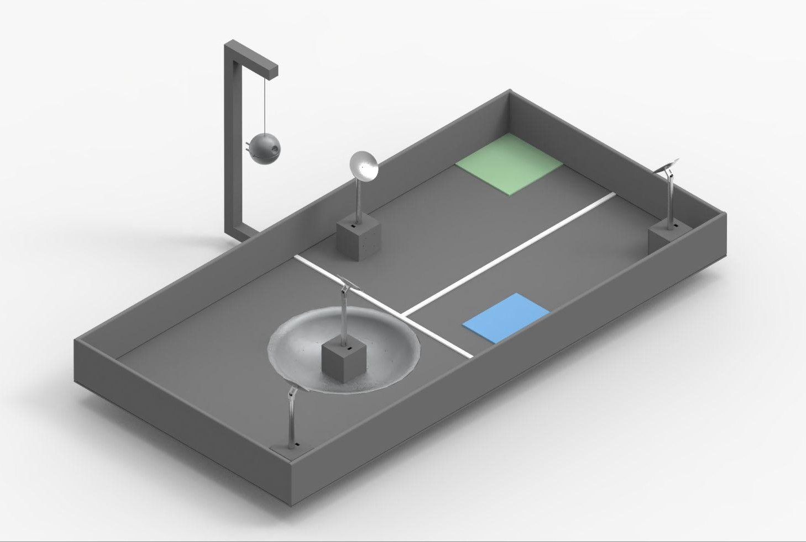

Figure - 3D Model of Playing Field



## Board Construction

Additional documentation is provided alongside this document. The additional documentation will go more in depth on the construction of the arena and the individual elements. Also, all code, wiring, and CAD models will be provided as well.

### Board General Construction

The construction of the competition board consists of materials that can be found at most every large hardware and home improvement retailer. The provided bill of material (6) includes the list of items, quantity of each item and links to the exact item used for this particular board.

**NOTE:** Actual wooden materials vary based on manufacturer's quality requirements. It is important to measure the hardware while purchasing and cutting/sawing to the provided instruction constraints.

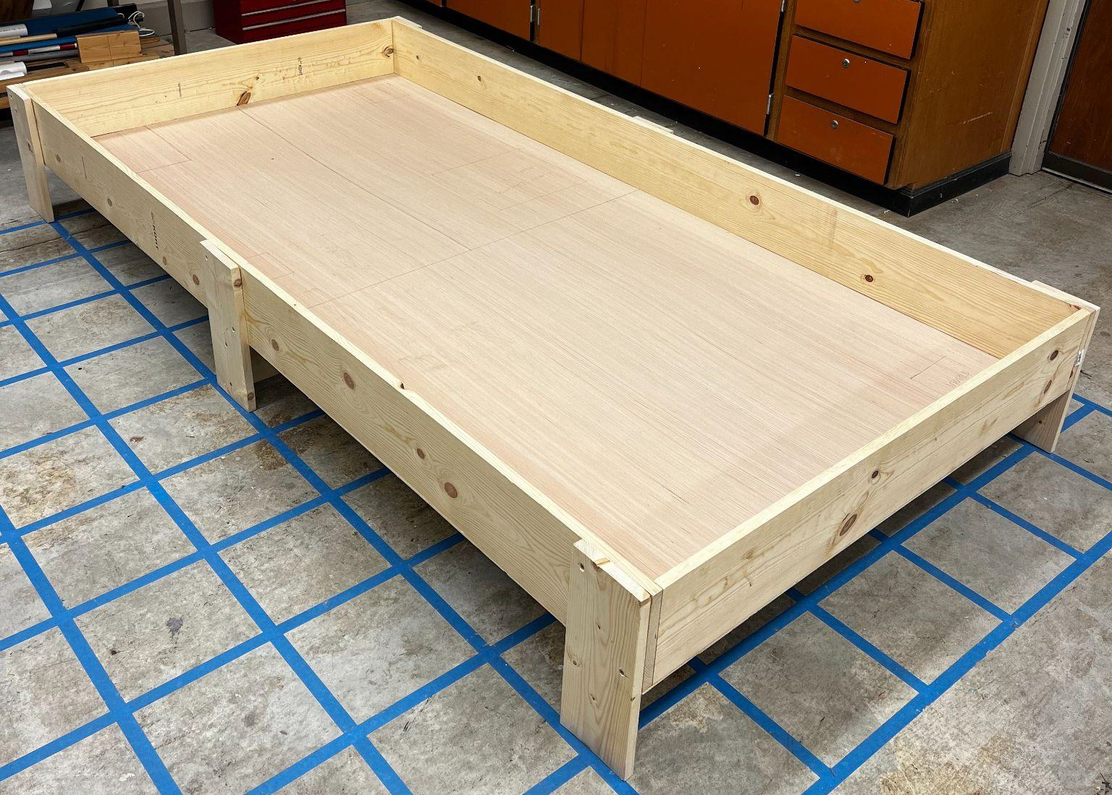

Figure - Playing Field Base

#### Board Base

The competition arena is based on a rectangular plywood sheet with exterior size of 4’ x 8’ and 5mm" thickness. The plywood sheet will be attached to the border walls using #8 1” cabinet screws. The use of cabinet screws will provide a better hold and reduce the problem of driving a regular wood screw through the thin plywood.

#### Border Walls

The arena border walls will be assembled with three 1” x 8” x 8’ square edged Unfinished Whitewood Boards. One 8’ board will be measured and cut into two sections of 46.5”. The two 8’ boards will be mounted vertically along the interior edge of the 8’ plywood base and the 46.5” boards will be mounted vertically along the short edge interior of the plywood base inside of the 8’ boards.

#### Legs

The arena will be supported by utilizing two 1” x 6” x 8’ square edged Unfinished Whitewood Board and 1-1/4" interior wood screws. One of the boards is cut into 6 segments, each measuring 14". One 14” board is mounted to each corner on the outside of the 8’ edge border walls, by four 1-1/4” interior wood screws. The remaining two 14” boards will be mounted on the center exterior of the 8’ side border wall with four 1-1/4” interior wood screws. This will give the board a lift of approximately 6.5”.

#### Stabilizing Joint

A single stabilizing joint will be placed between the center 2 legs of the arena board and will be assembled with one 1” x 6” x 6’ square edged Unfinished Whitewood Board and 1-1/4". Interior Wood Screws. The board should be cut to measure 48” and mounted in the center of the interior of the two middle legs on the underside of the board.

#### Start LED bar

Two starting white LED bars will be placed on top of the arena wall, one on each side of the 12”x12” starting area. These LED’s will be centered in the 12” length of each side of the starting area. They will turn on for approximately 1 second to indicate the start of the round for the robot.

#### Earth Arm Construction

The Earth arm will utilize a single 2” x 2” x 8’ wood post. The post will be cut into 3 segments. Segment 1 will measure 22”, Segment 2 will measure 40”, and Segment 3 will measure 10”. Segment 1 slides under the board on the starting square side at the middle leg. It will be fastened to the wall using a 2” angle bracket. This segment will extend 11” out from the wall with the other 11” underneath the arena. Segment 2 will be placed vertically attached to the end of segment 1. One wood screw can be used to attach the segments and then a 2- inch angle bracket will also be used on both sides of the connection (one on top and one on bottom). The top of segment 2 will be cut at a 45 degree angle and one side of segment 3 will be cut at a 45 degree angle. Segment 3 will be attached to segment 2 using the 45 degree angles to create a 90 degree corner. A 2” angle bracket will be used at this corner and one wood screw will be used to join the two pieces as well. An eyehook will be put into segment three centered at 2” from the end of the segment closest to the field of play. Reference figure 3 for how the final arm assembly will look once constructed.

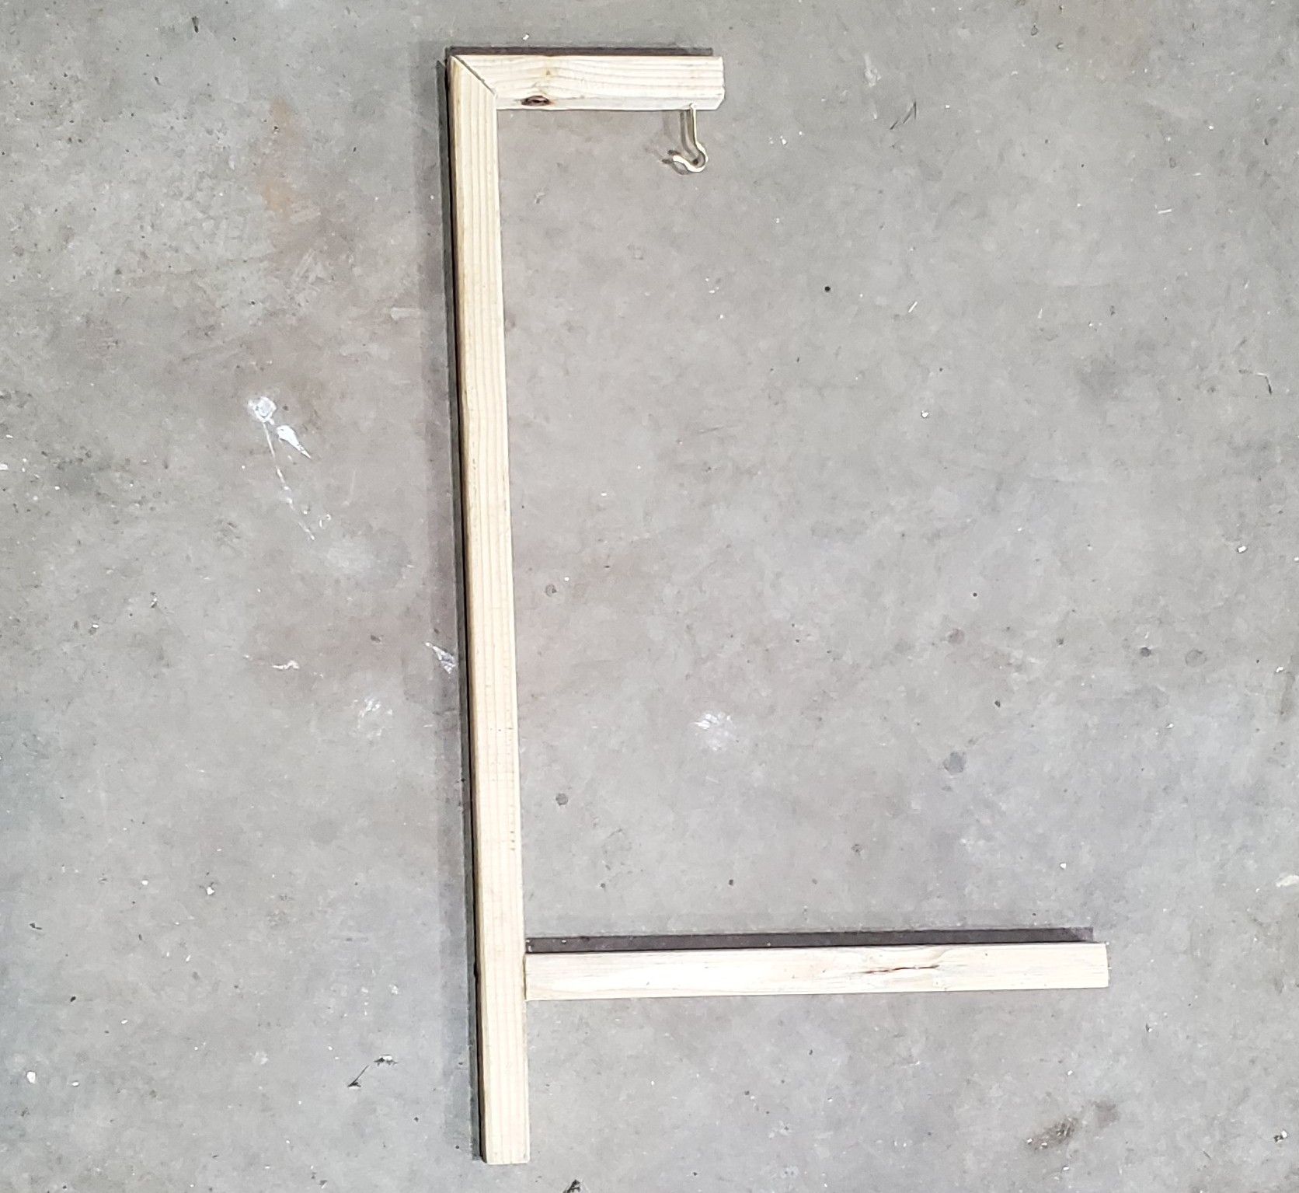

40”

10”

22”

11”

Edge of Arena Wall

Segment 1

Segment 2

Segment 3



40”

10"”

22.5”

11”

Edge of Arena Wall

Figure - Earth Arm Assembly

### Crater Construction

The Crater will be 2’ in diameter with a downward slope into an 8” diameter flat area. It will be fully 3D printed and affixed to the playing field. It will also be supported by a sheet of plywood attached underneath the playing field. Due to a rough printing area of 5.5” x 5.5” x 5.5” available in many 3D printers, the Crater will consist of 4 main part types that will be duplicated and assembled to create the Crater. See *3D-Printed Part Assembly Guide* for full assembly instructions of the Crater and *3D-Printing Guide* for instructions on printing each part.

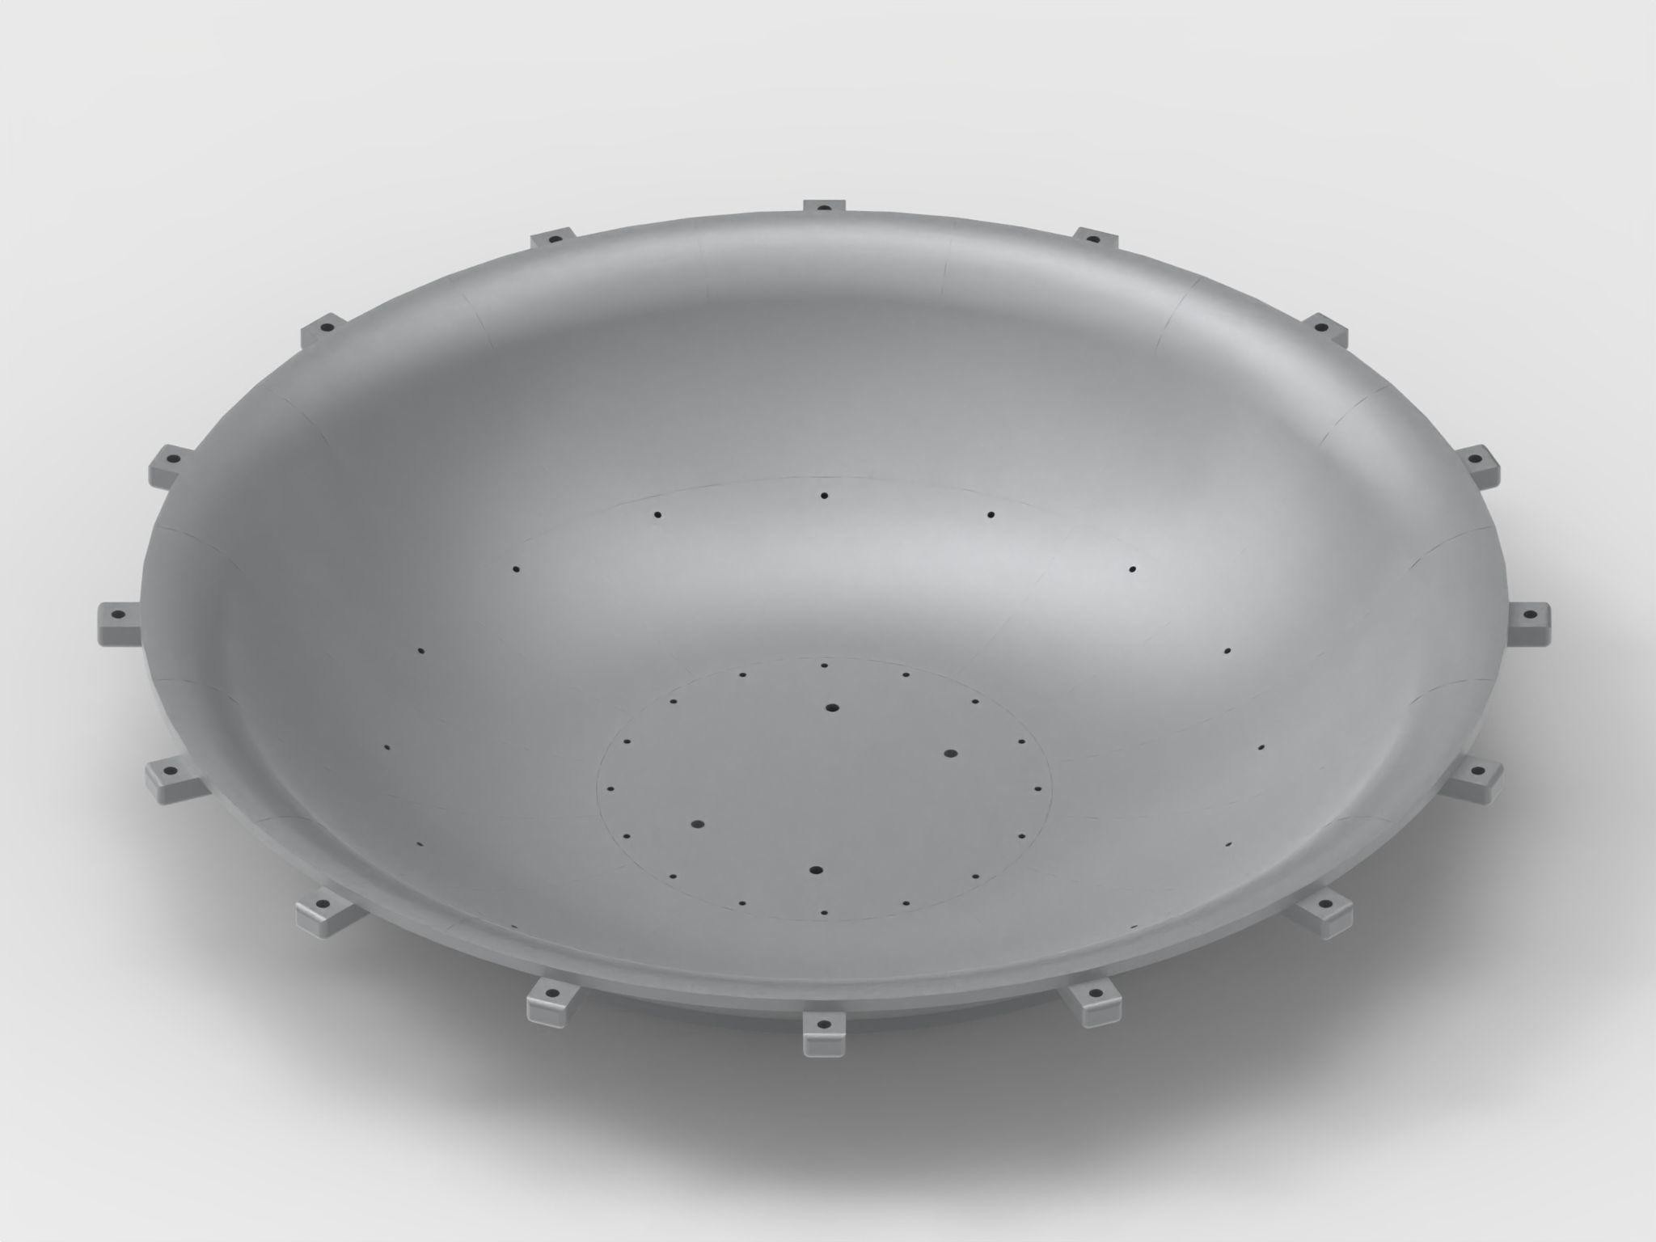

Figure - Crater Rendering

### Crater Part Description

#### Crater Upper Rim

The first part is the outer diameter of the crater. The crater requires 16 copies of the *Upper Rim Piece*. This part will have 2 holes. 1 hole will be located on the upper side of the part and another on the lower side. Additionally, the *Upper Rim Piece* will have a lower lip located on the bottom such that *Lower Rim Piece* can rest upon it. The hole on the upper side of this part be a ¼” and will be used to attach the crater to the playing field via a bolt.

#### Crater Lower Rim

The second part of the crater is the inner diameter of the crater. The crater requires 16 copies of the*Lower Rim Piece*. Similar to the *Upper Rim Piece*, this part will have 2 holes. One hole will be on the upper side and will align with the lower hole of the *Upper Rim Piece*. The other hole will be located on the lower side of this part and will be used to attach the curved area of the crater to the flat area at the bottom of the crater. The *Lower Rim Piece* will also feature a lower lip at the bottom of the part such that *Flat Area V1 or Flat Area V2* can rest upon it.

#### Crater Flat Area V1

*Flat Area V1* will be part of the flat area located at the base of the crater. The crater requires two copies of *Flat Area V1*. The two *Flat Area V1 pieces* must be placed opposite each other during construction. Flat Area V1 will resemble a quarter-circular plate with an upper lip that rests on the lower lip of Lower Rim. *Flat Area V1* will have 4 holes on the outer edge of the part which will align with the lower hole of the *Lower Rim Piece*. This part will also have a 1/4” hole located near the center such that Antenna #3 and the Crater can be mounted to the supporting plywood platform underneath the playing field.

#### Crater Flat Area V2

*Flat Area V2* is the mirrored version of *Flat Area V1* which is required to mount the antenna in the base of the crater. Two copies of this part are required for antenna construction. The two *Flat Area V2 pieces* must be placed opposite each other during construction. *Flat Area V2* will resemble a quarter-circular plate with an upper lip that rests on the lower lip of Lower Rim. *Flat Area V2* will have 4 holes on the outer edge of the part which will align with the lower hole of the *Lower Rim Piece*. This part will also have a 1/4” hole located near the center such that Antenna #3 and the Crater can be mounted to the supporting plywood platform underneath the playing field. Once all four flat area pieces are assembled, the flat area will span 8” in diameter. When connecting the flat area to the *Lower Rim Pieces*, make sure that the holes for mounting the antenna are positioned so that the antenna can be mounted in the indicated orientation in Figure 6 and in Figure 8.

#### Crater Line

In order to determine being “in” the crater for scoring purposes, a thin white line will be painted 3” from the lip of the crater. This will be on the upper rim pieces, on the second crease from the bottom, as shown in Figure 5.

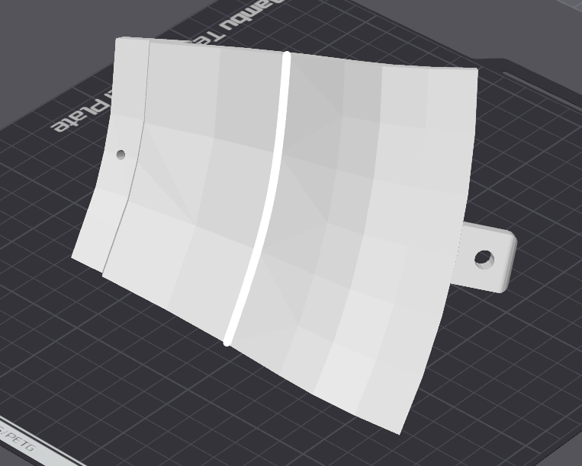

Figure Crater Line

## Playing Field Areas

The competition playing field will be divided into 4 main areas. The areas will feature 1 antenna and 1 Astro-Duck in areas 1, 2 and 4, and 3 Astro-Ducks in area 3. Six Astro-Ducks in total will be distributed across the playing field. The Astro-Ducks will be placed randomly in their designated areas while all other items will be in the locations shown in Figure 6 below. The Placement of the Astro-Ducks will be in the approximate locations shown in Figure 6.A diagram of a satellite

Figure - Areas of Playing Field. The north wall is at the top of this drawing.

### Area #1

Area #1 is the blue shaded area located in the lower left quadrant of the arena, it also accounts for 25% of the total playing field. Area #1 contains the Starting Area, Antenna #4, and 1 Astro-Duck.

### Area #2

Area #2 is the green shaded area located in the upper left quadrant of the arena, and accounts for 25% of the total playing field. It will feature Antenna #1, 1 Astro-Duck, and the Lunar Landing Area. The Lunar Landing Area will function as the Astro-Duck gathering zone.

### Area #3

Area #3 the purple shaded area in the right half of the arena, it accounts for approximately 40% of the total playing field. Area #3 is the largest area, and as such will contain Antenna #2 and 3 Astro-Ducks.

### Area #4

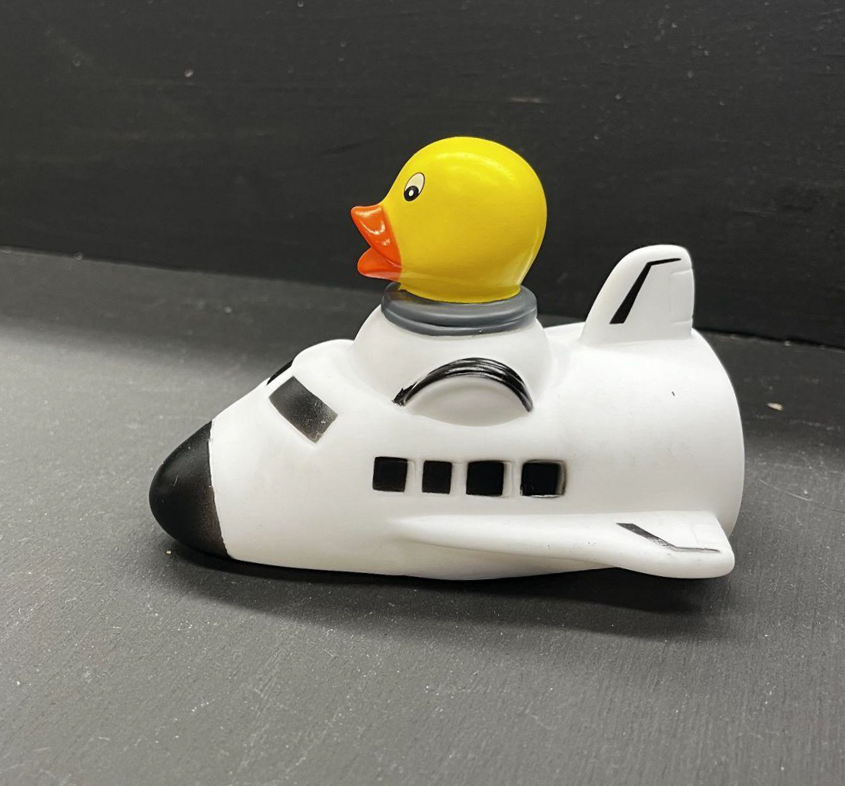Area #4 is the red shaded area located on the right side of the arena inside Area #3, it accounts for approximately 10% of the total playing field. This is the most unique area on the playing field as it is a 2’ diameter crater with an 8” circular flat area at the bottom. Antenna #3 will sit at the bottom of the crater along with 1 Astro-Duck resting on top of Antenna #3. A line will be drawn around the crater 3” down from the edge of the crater. This line will be used to determine one of the scoring possibilities for the competition. See section 2.1.3.5 for placement of the line.

Figure - Astro-Duck

### Astro-Duck Placement

For the Astro-Duck placement, all Astro-Ducks will be placed face up as shown in Figure 7. No Astro-Duck will be within 2” of the separation line between two zones. Astro-Ducks will also not be within 2” of Antenna #1, #2, and #4 nor will they be within 2” of the playing field walls nor within 2” of the grey edge of the crater. Orientation of the Astro-Ducks will be random and they will be placed in the approximate areas shown on the playing field in Figure 6. Competitors can expect a large variance in Astro-Duck placement based on the approximate areas shown.

### Painted Zones

For the board, the base plywood, the arm for the Earth, and the walls will all be painted black. The crater will be 3D printed using grey filament. The starting area will be painted green and the Lunar Landing area will be painted blue. The area under antennas #1, #2, and #4 will be painted white. The lines used to separate Area #1, #2, and #3 will be indicated with a painted solid white line. The line will be 1.5” +/-0.25” thick being centered on the zone separation lines indicated in *Areas of the Playing Field* in Section 2.2 causing 0.75” of the line to be in each zone.

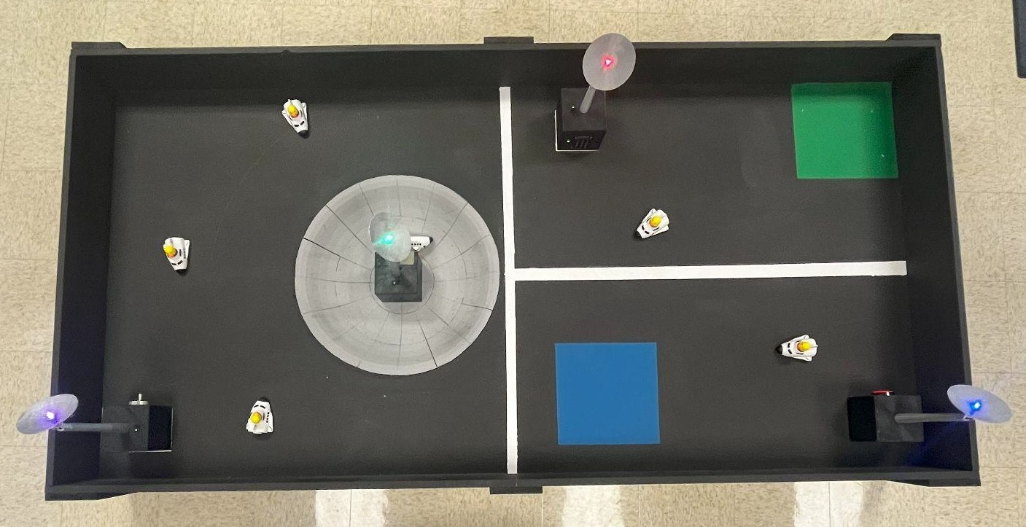

Figure - Painted Board with Completed Antennas and Potential Duck Placement

## Antenna Construction

There will be four antennas placed on the board, and each antenna will be in the designated area shown in Figure 6 in section 2.2. There are four different antenna designs, and while the base will be the same, there are some slight differences in each design to account for the different tasks. The cube at the base of the antenna will be matte black, and the stand and dish of the antenna will be grey**.** The color and shape of the antenna is shown in Figure 9 below.

All the antennas will also have some electrical components in order to read the task and power the antenna when appropriate. All components will be stored within the 5” cube antenna base with the sliding hatch door closed. Power being restored for the antenna will be indicated two ways with an indicator LED on the sign of the 5” base and an LED placed in the center of the dish. When an antenna is turned on the LED in the dish of the antenna will turn one of four colors: red, blue, green, and purple. The color of the LED will not be provided beforehand, but it will be one of the 4 specific colors

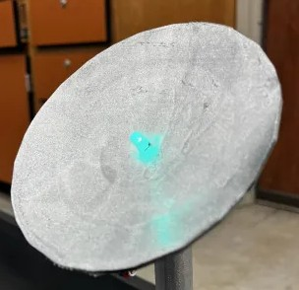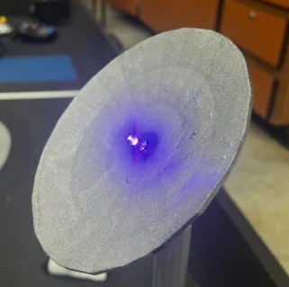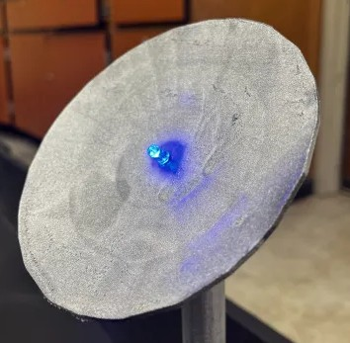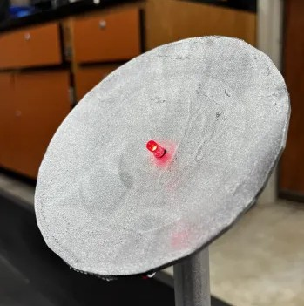

Figure - Antenna Color Examples

Once the team completes a task on an antenna which restores the antennas power and turns on the LED in the antenna dish, it will not turn off unless the antenna is manually reset.

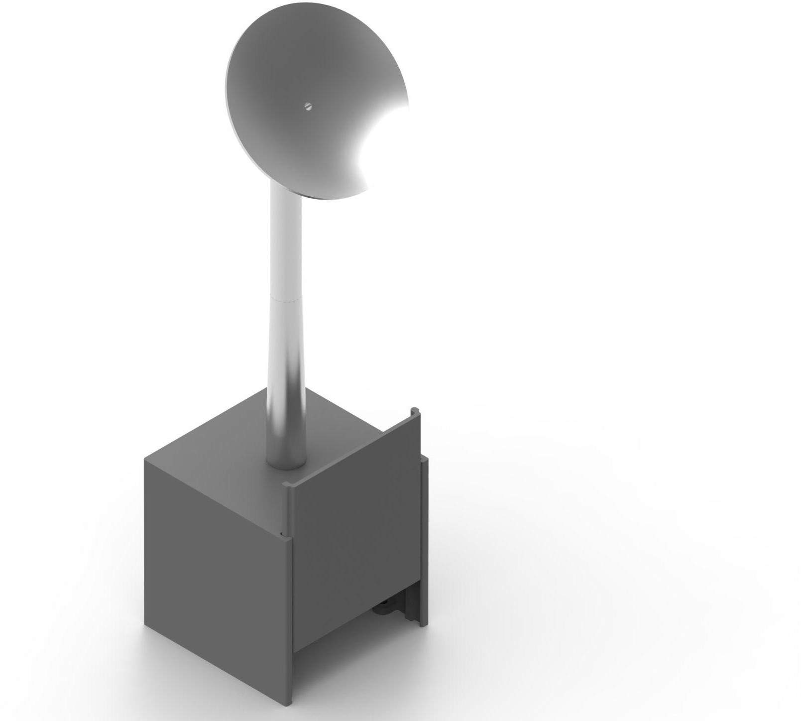

Figure - 3D and Fully Constructed Base Model of Antenna

The antenna base has 4 interior mounting points which will be used to fasten the base to the playing field. 4x 4-40 ¾” bolts will be used to attach the base to the playing field. The antenna stand consists of 2 cylindrical parts, each part will simply slide together along the cylindrical axial and be glued in place. Once the antenna shaft is assembled it will slide onto a small cylindrical protrusion on top of the antenna base. Finally, the antenna dish will slide onto the top of the antenna shaft along the 2 notched guidelines.

The antenna will be constructed where the dish of the antenna is in line with the task placed at the base of the antenna. This will cause both the LED on the base of the antenna and the LED in the dome of the antenna to be orientated in the same direction. Thus, when it is stated that an antenna is facing in a direction that means the LED in the dome and LED on the side of the box are facing that direction. Additional details will be provided in the document titled “Antenna Construction Documentation.”

### Antenna #1

Antenna #1 will be located in Area #2 and the dome will be facing the south wall of the playing field**.** This antenna will have a button task.

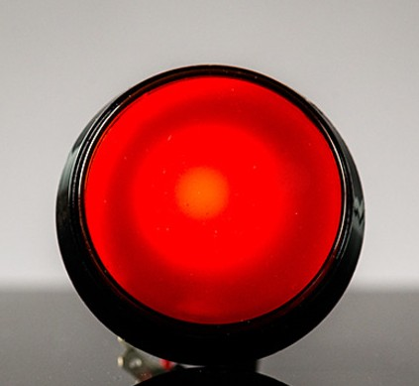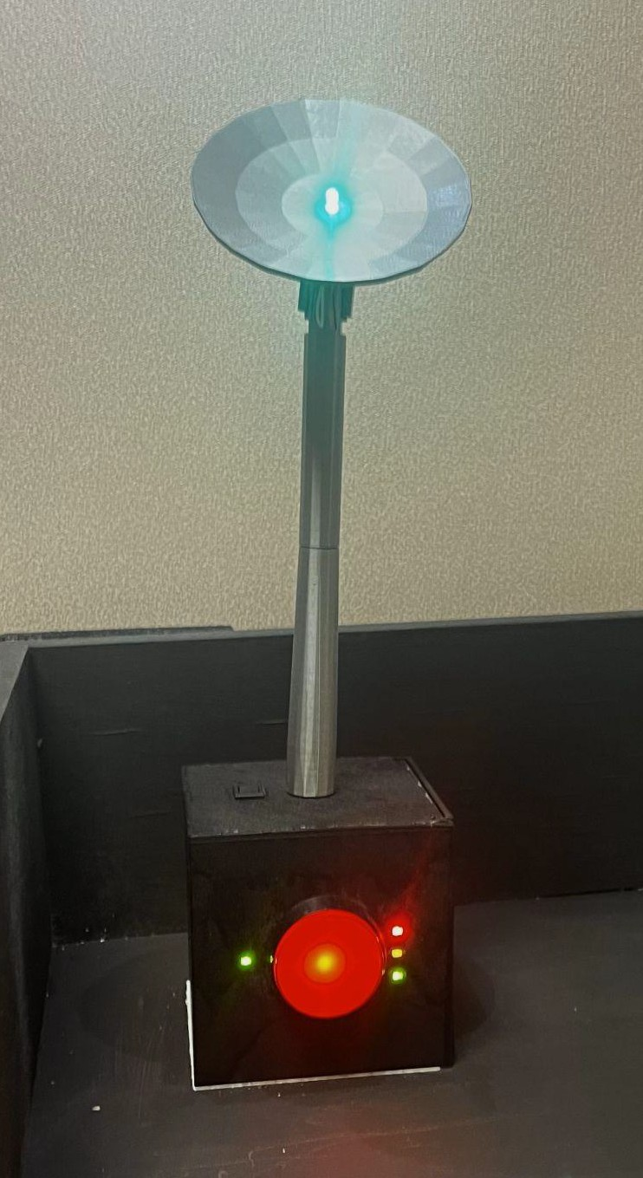

Figure - Antenna #1 Task and Built Antenna

As shown in Figure 11 a button will be placed on the side of the 5” cube antenna base. In order to turn on the antenna, the button needs to be pushed 3 times in total. The antenna has 4 additional LEDs placed on button side of the antenna base. On the right side of the button there are 3 vertical LEDs. The top LED will be red, the middle LED will be yellow, and the bottom LED will be green. The LEDs will turn on corresponding to how many times the button has been pressed. When the button is pressed once, the red LED will turn on. When the button is pressed for the second time the yellow LED will turn on. Then when pressed for the third time the green LED will turn on. The third push will also fully restore power to the antenna causing the LED in the antenna to turn on to a random color of red, blue, green, or purple. Furthermore, a green LED to the left of the button will turn on indicating that the task is completed (reference Figure 11 above).

### Antenna #2

Antenna #2 will be located in Area #3 and will be facing the south wall of the playing field. This antenna will have a crank task.

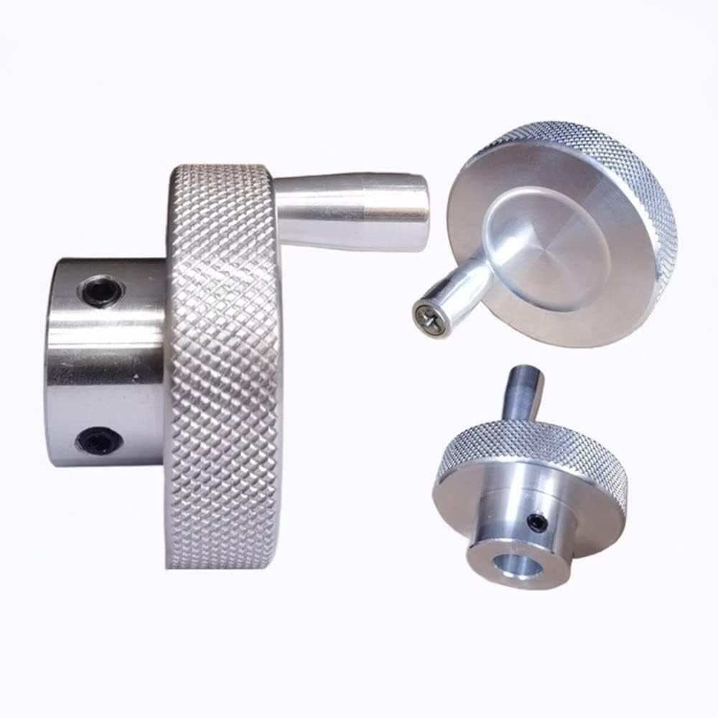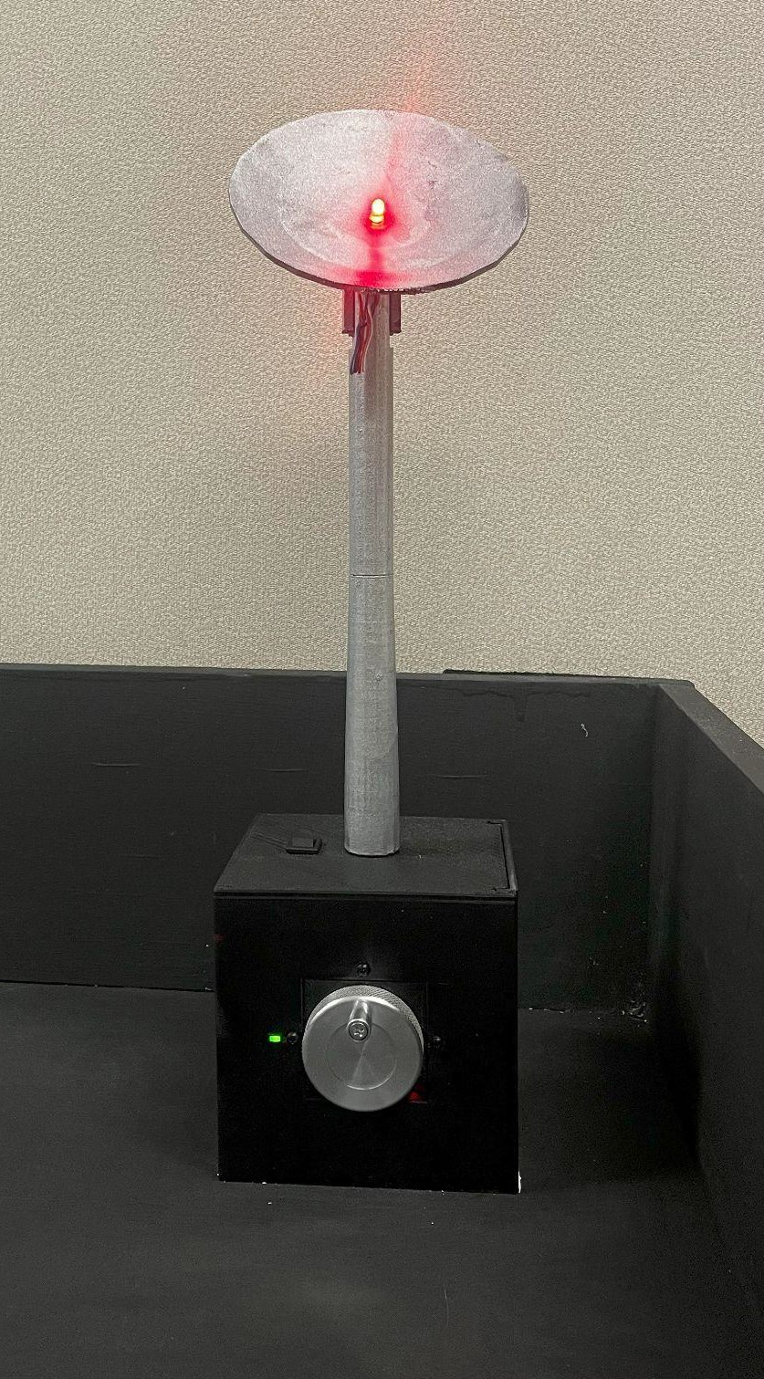

Figure - Antenna #2 Task and Built Antenna

Antenna #2 will have a crank mounted on the side of the antenna base. The crank will start with the handle at the very top as shown in Figure 13. The robot needs to rotate the crank 540 degrees clockwise or counterclockwise. Once the crank has been rotated at least 540 degrees, the LED in the antenna will turn on to a random color of red, blue, green, or purple Furthermore, a green LED to the left of the crank will turn on indicating that the task is completed (reference Figure 12). Note: the programming will be for 360 degrees. 540 is stated as the requirement because during testing sometimes the crank had to go about 45 degrees more than 360 degrees.

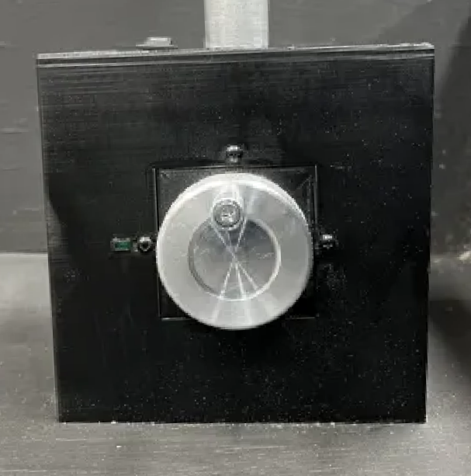

Figure - Antenna #2 Starting Position

### Antenna #3

Antenna #3 will be located in Area #4 and will be facing the west wall of the playing field**.** This antenna will have a pressure plate task.

Figure - Antenna #3 Task and Built Antenna

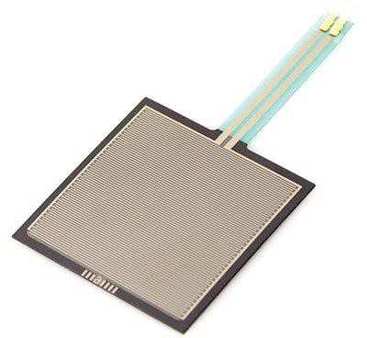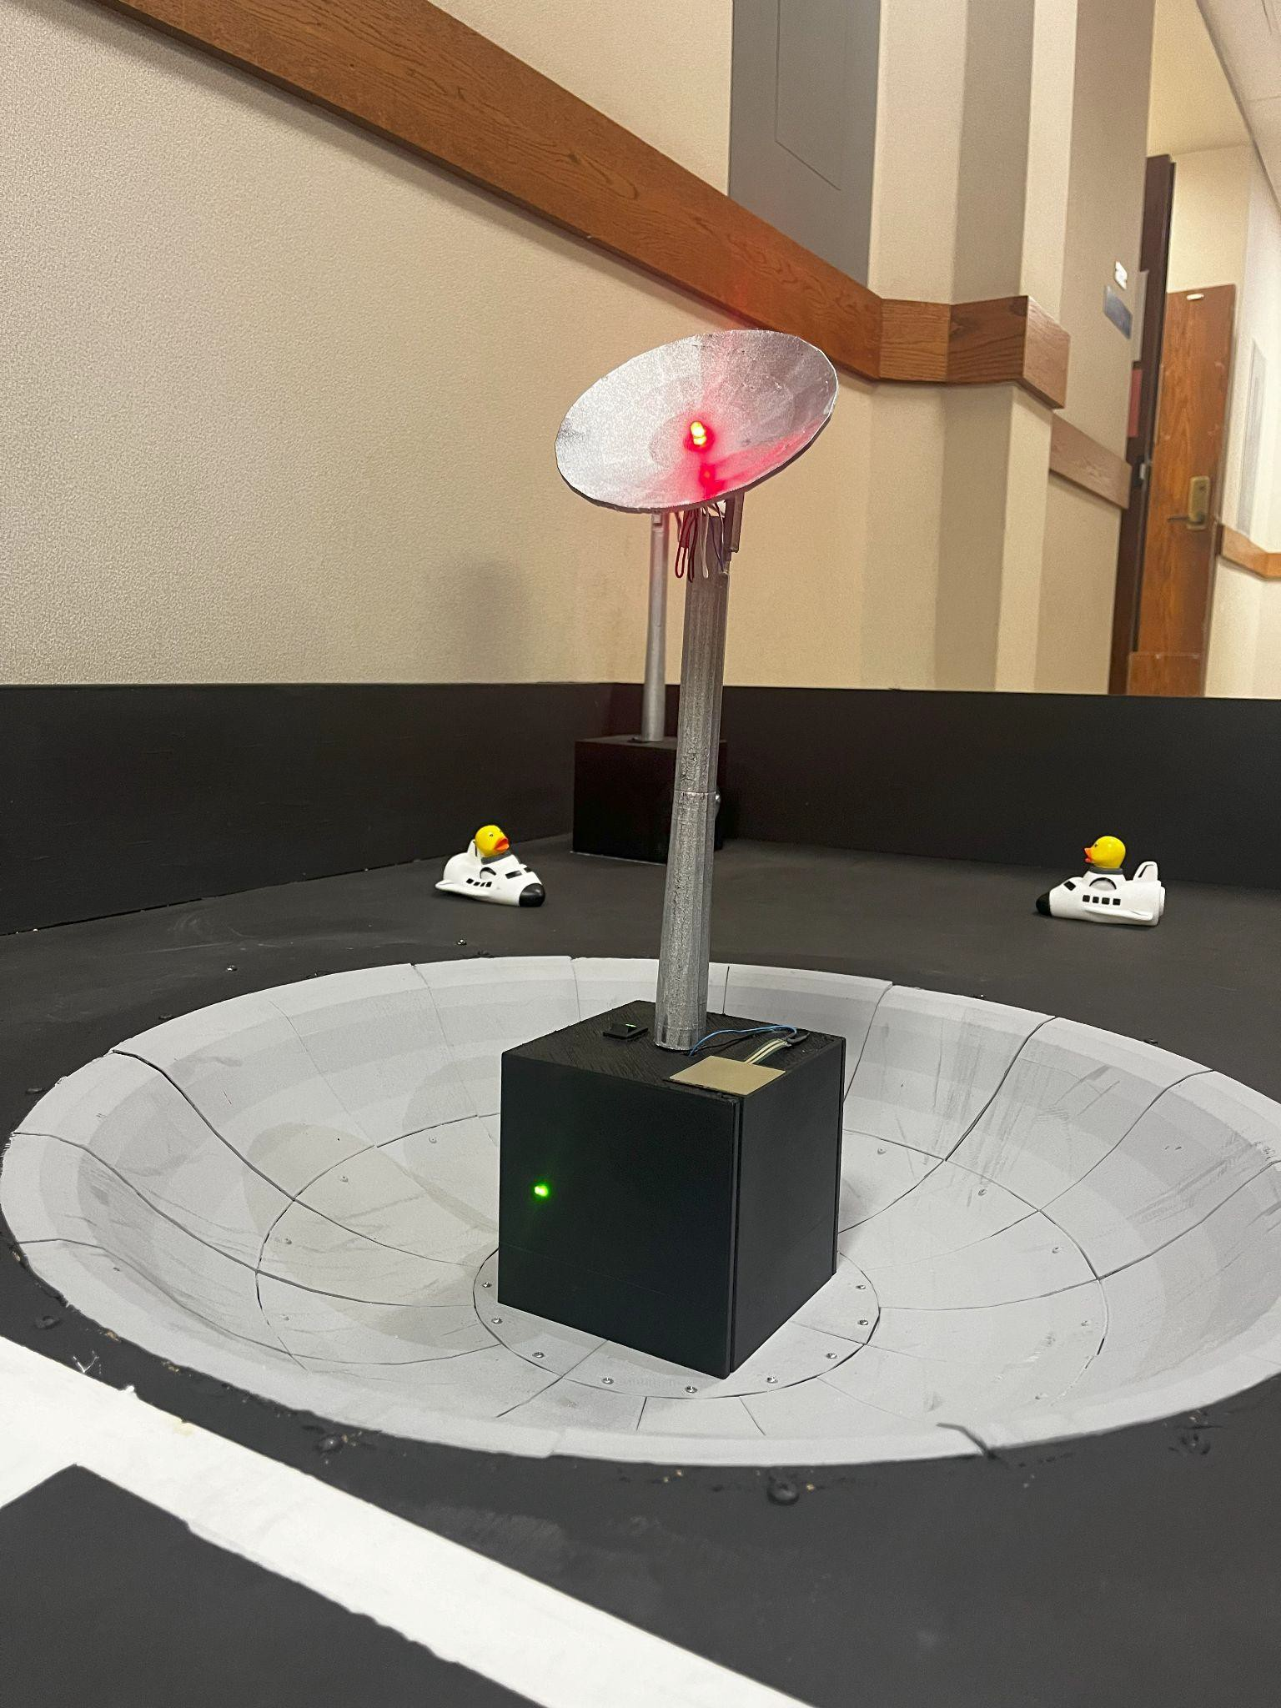

A pressure plate will be mounted on top of the antenna base with an Astro-Duck placed on top. The Astro-Duck will be placed right side up centered on the pressure plate. The team needs to remove the Astro-Duck from the top of the pressure plate. When the Astro-Duck has been successfully removed from the pressure sensor, the LED in the antenna will turn on to a random color of red, blue, green, or purple. Furthermore, a green LED on the front of the antenna base will turn on indicating that the task is completed (reference Figure 14). The Astro-Duck stranded on the antenna is one of the six Astro-Ducks that needs to be returned to the Lunar Landing Area.

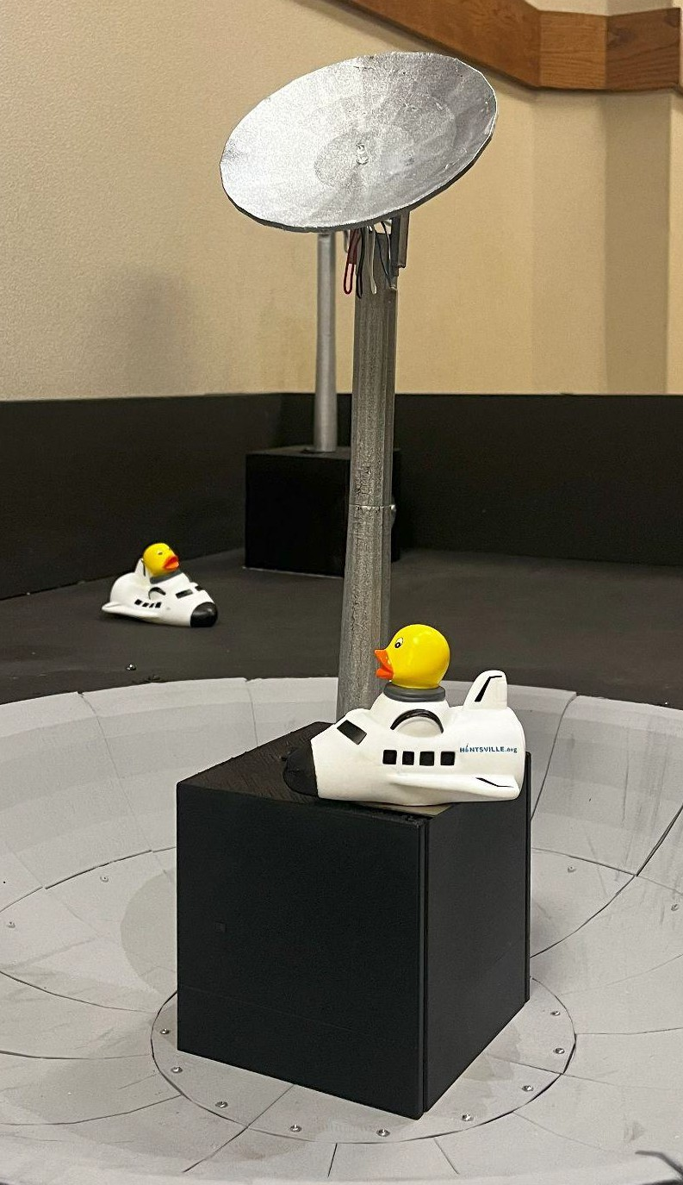

Figure - Antenna #3 Starting Position

### Antenna #4

Antenna #4 is a keypad task. The antenna will be located in Area #1.

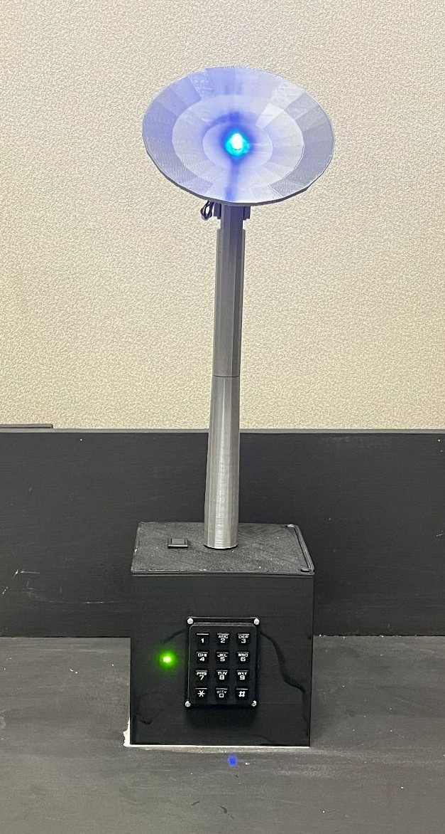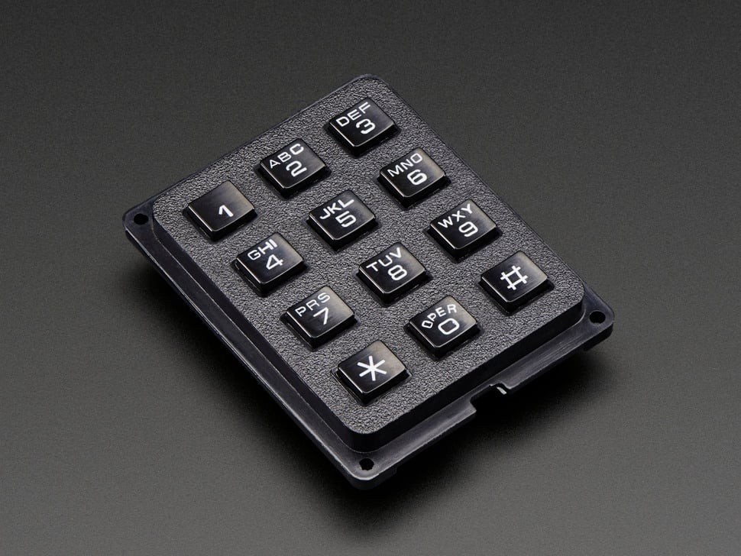The keypad will be located on the side of the antenna base as shown in Figure 16 and the keypad will be facing the north wall of the playing field. In order to restore power to antenna #4, the robot needs to input the code 73738# which corresponds to “RESET” using the dial letters on the keypad. Once the code has been successfully entered, the LED in the antenna will turn on to a random color of red, blue, green, or purple Furthermore, a green LED to the left of the keypad will turn on indicating that the task is completed (reference Figure 16).

Figure - Antenna #4 Task and Built Antenna

## Earth Construction

### Basic Construction

The Earth will also be 3D printed using grey filament. All electronic components besides the IR receiver and LCD will be placed inside as illustrated in Figure 17. Once fully assembled the Earth will be attached to the support arm attachment on the playing field. The bottom of the earth will be 20” +/- 1” from the arena playing surface. The LCD will track all points gained through transmission with the Earth and the Arduino will also keep record of all transmissions which can be used to verify the LCD’s score. See 3D-Printed Part Assembly 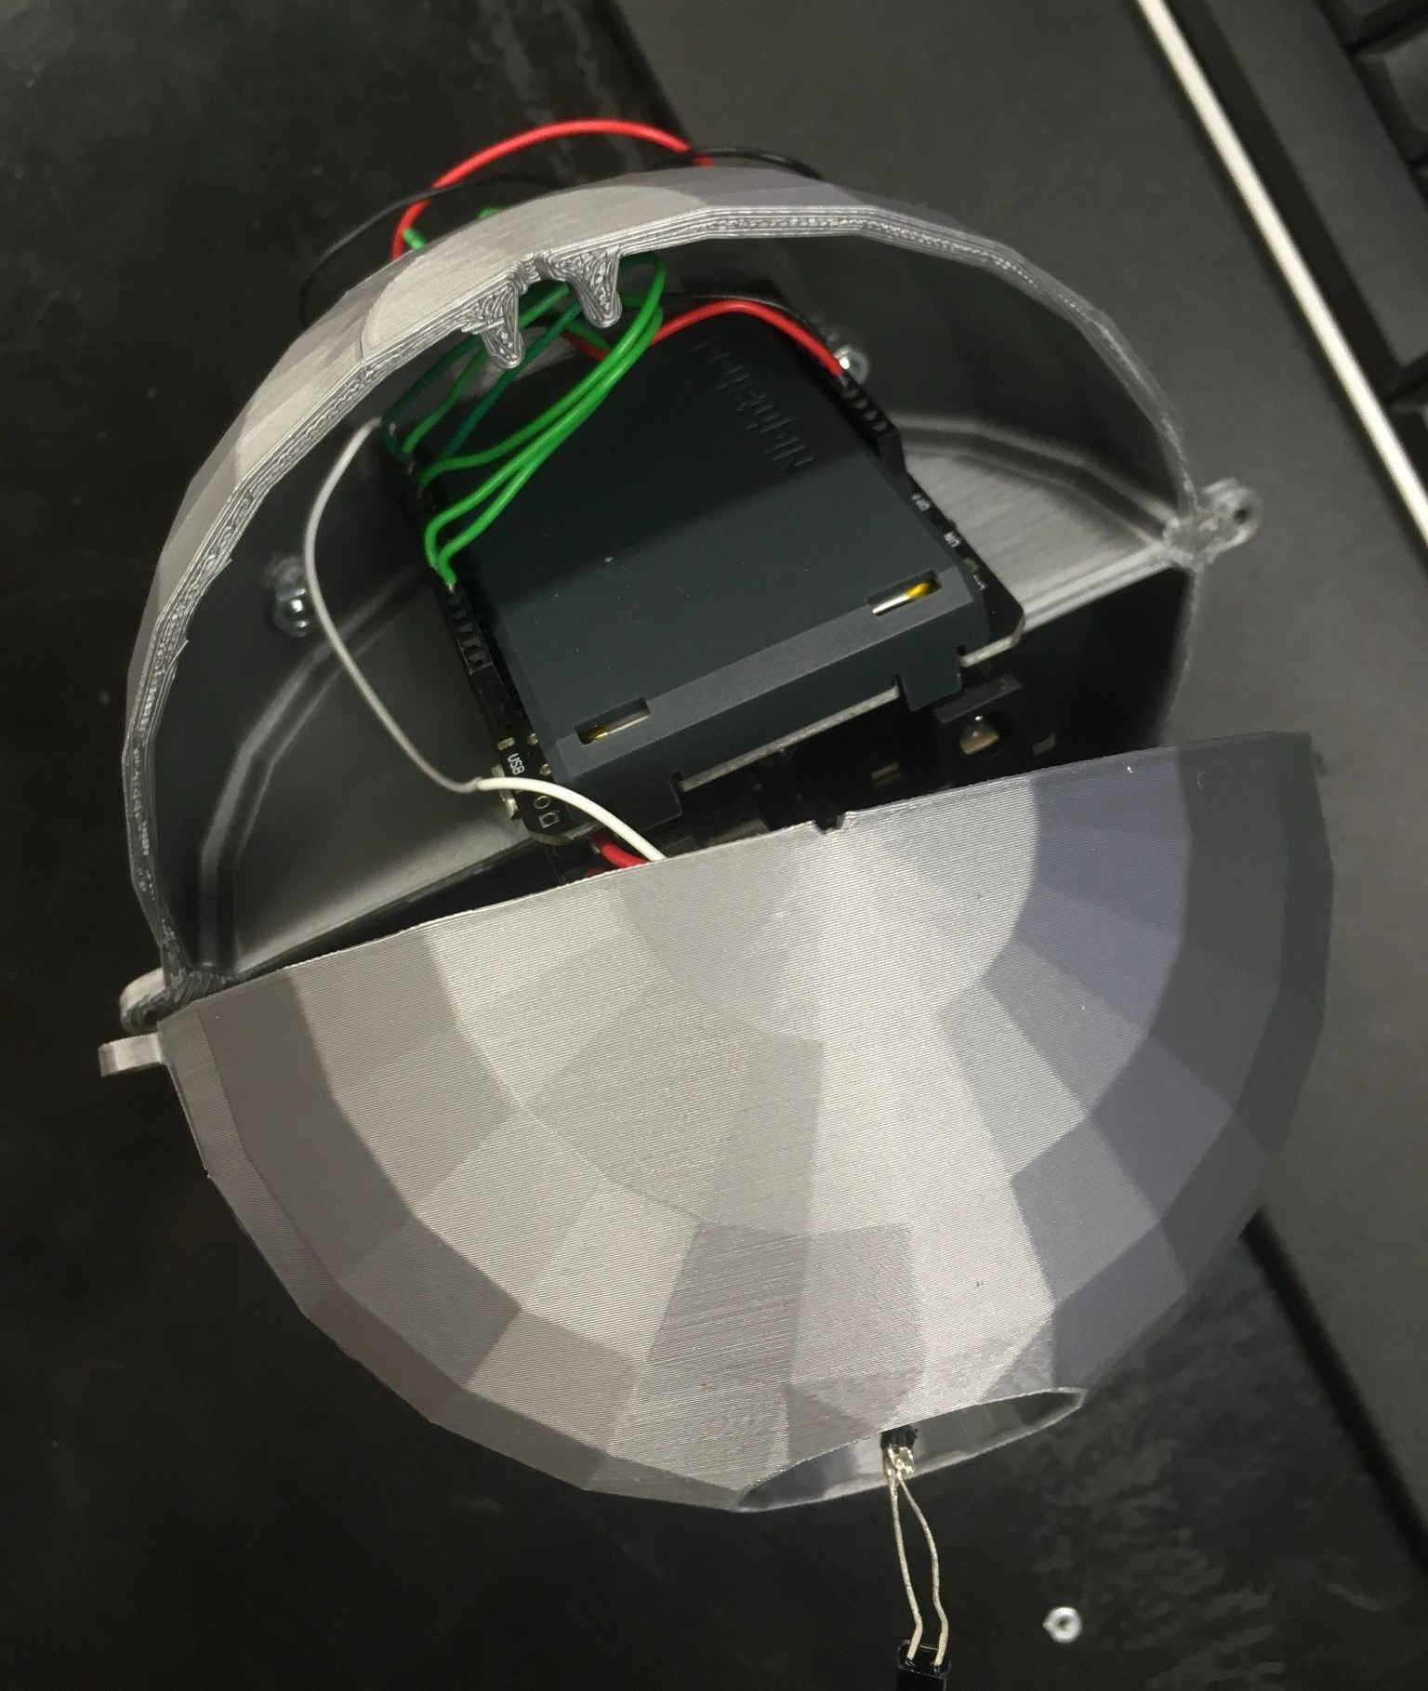for full assembly instructions of the Earth.

Figure - Earth Electrical Component Placement

Transmission to Earth will be accomplished using a 38 kHz IR receiver. The IR NEC protocol will be used. The Arduino library IRremote has the protocol defined. The code for Earth and also code to test transmissions is provided. The address will be 0xBB. The codes for the antennas and LED colors will form the 8 bit command, with the antenna being the first 4 bits and the color being the last 4 bits. The codes are as shown in Table 1.

Table IR Transmission Codes

|  |  |  |  |
| --- | --- | --- | --- |
| Antenna Number | Antenna Code | Color | Color Code |
| 1 | 0x00 | Red | 0x09 |
| 2 | 0x30 | Green | 0x0A |
| 3 | 0x50 | Blue | 0x0C |
| 4 | 0x60 | Purple | 0x0F |

For example, to transmit the information that Antenna 3 is Blue, the command in hex would be 0x5C.

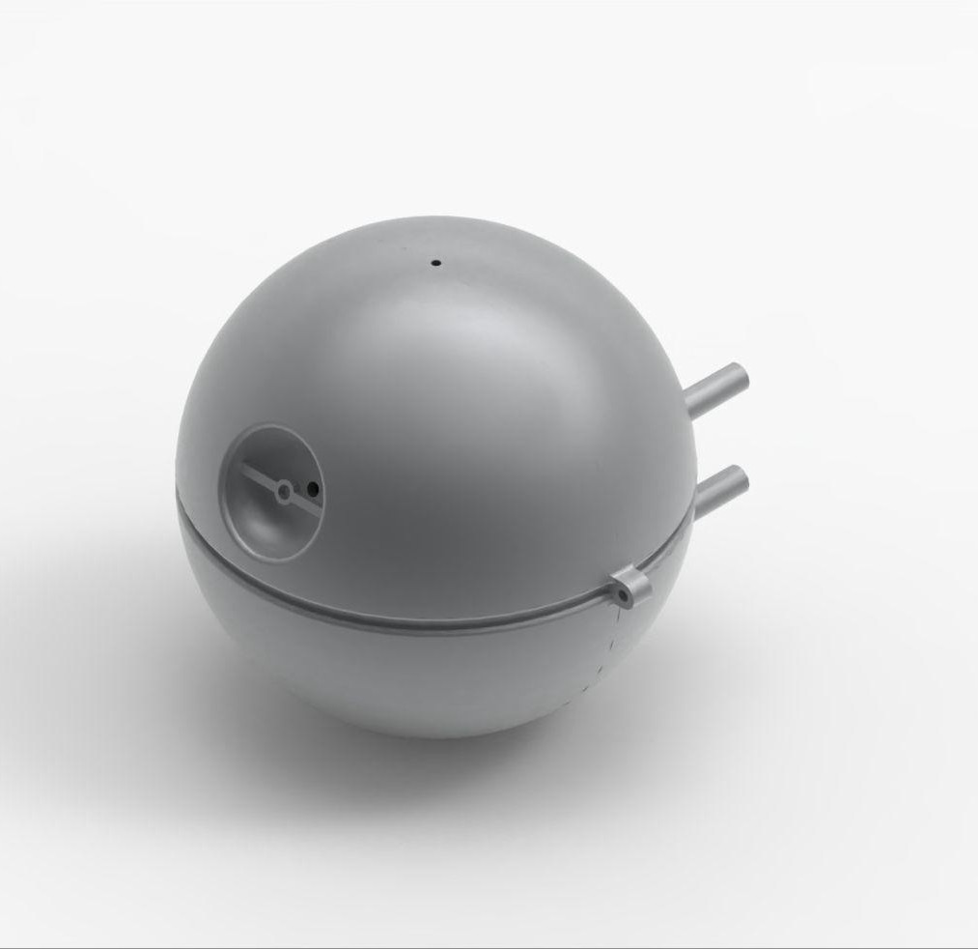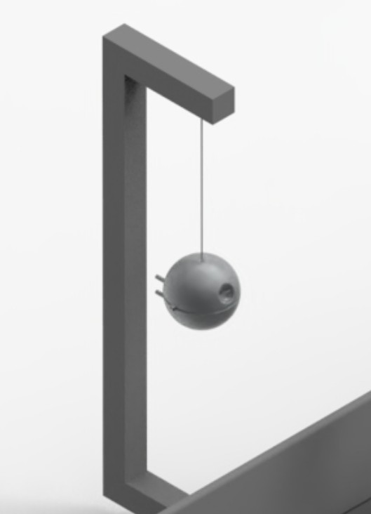

IR receiver will be mounted here

Figure - 3D and Constructed Model Rendering of Earth 3D Part Description

### 3D Part Description

1. Shell V1

*Shell V1* is 1 hemisphere of the total Earth design. It has a small hemispherical cavity which features a small hole and a mounting point. The IR receiver used to receive communications from the UAV will be mounted on the cross-piece that goes across the cavity. A small amount of glue will hold it in place and the wires will be fed through the hole inside the cavity. A hemispherical hole is located at the top of *Shell V1* such that the suspending cable can enter into the center of the Earth. *Shell V1* also has 2 mounting holes on either side of the hemisphere which will be used to affix *Shell V1* to *Shell V2*.

1. Shell V2

Similar to *Shell V1*, *Shell V2* is a hemisphere that will make up the entire spherical design of the Earth when affixed to *Shell V1*. *Shell V2* features 4 cylindrical mounting holes protruding from the hemispherical face. These mounting holes will be used to affix the LCD to the back of the Earth. It also has 2 mounting holes on either side of the hemisphere which will be used to affix *Shell V1* and *Shell V2*.

1. Earth Hook

*Earth Hook* is a small cylinder with a hole. The mounting cable will be inserted through the hole and affixed with a clamp such that it cannot pass back through the hole. When *Shell V1* and *Shell V2* are affixed together, Earth Hook will set inside the 2 hemispherical parts such that the mounting cable passes through the small hole at the top of *Shell V1* and *V2*. This will allow for the Earth to be upheld by the mounting cable.

# Rules of Play

## Hardware Competition Rounds

The hardware competition will have 3 different rounds: qualifying, semi-final, and finals. For the qualifying and semi-finals rounds, multiple boards will be used to run the competition simultaneously. Below is a breakdown of the different rounds for the hardware competition

### Qualifying

All teams will participate in the qualifying round. A play order will be assigned prior to the competition beginning. This play order will be repeated three times in total allowing each team to have 3 total rounds. The team’s two highest scoring rounds will be added together to get the team’s qualifying score. The top 16 teams will move on to the semifinals.

### Semifinals and Finals

The 16 teams with the highest qualifying round score will participate in the semifinals. The semifinals will be a single elimination bracket competition where each playoff will consist of two teams. Each of the teams will get one run of the playing field. The team with the highest points will move on to the next round. The team’s placement in the bracket will be determined by the number of points scored in qualifying with the team with the highest qualifying score being #1, the next highest being #2, etc. During the semifinals, 4 boards will be used for the first round, 2 boards for the second and third rounds and 1 board for the last round.

The bracket will be as follows

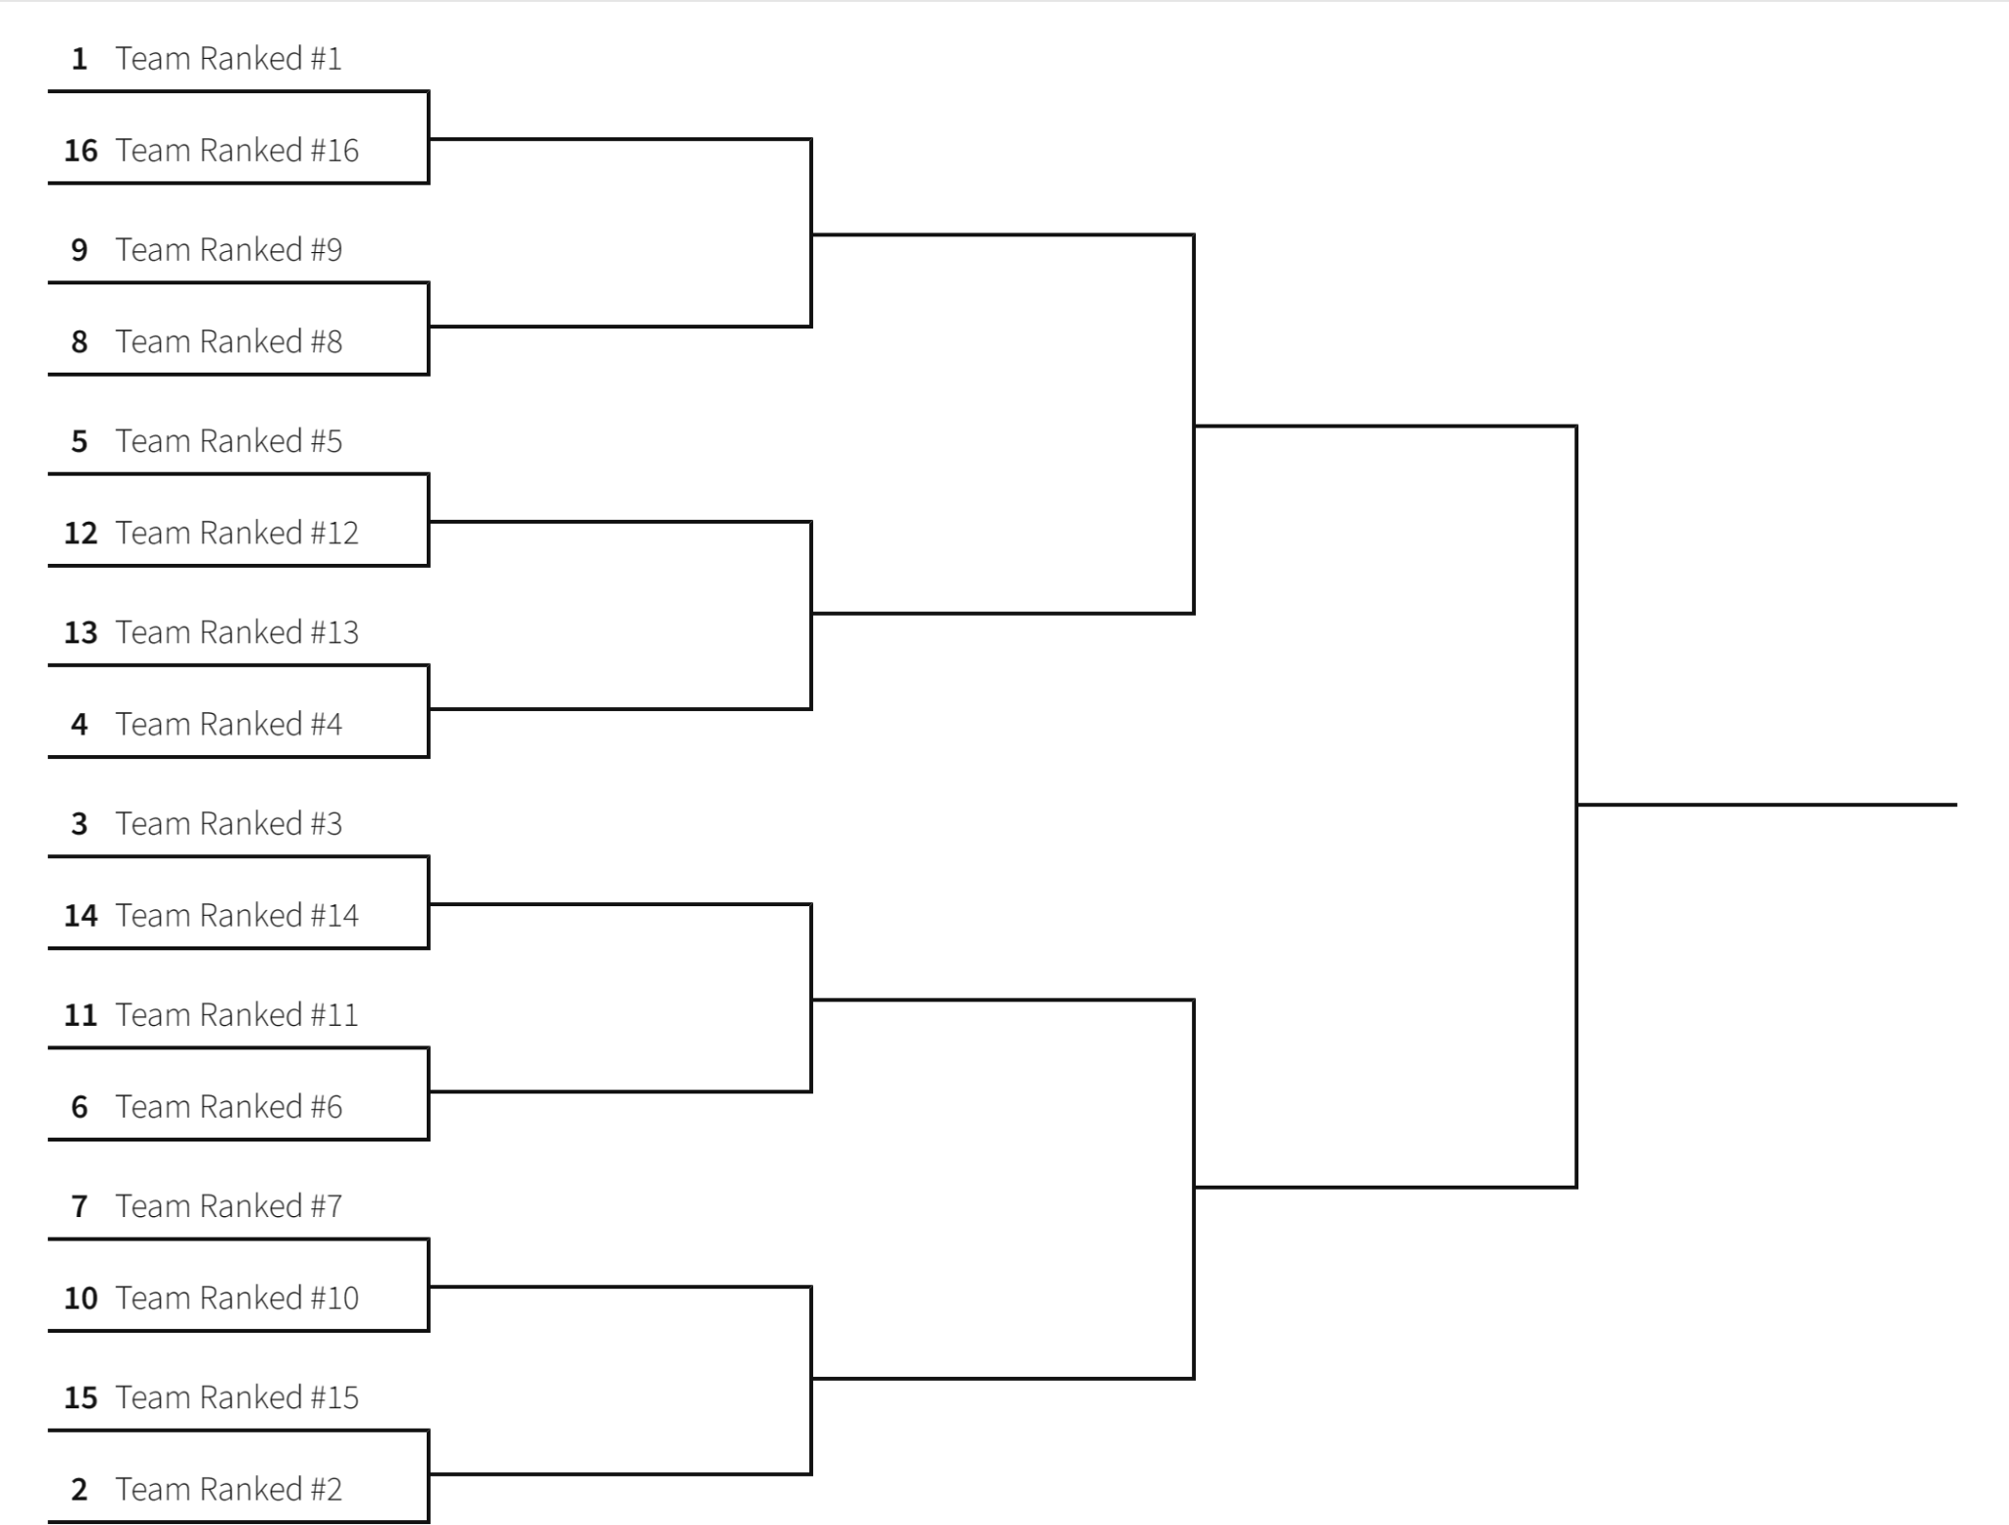

Figure - Competition Bracket

The bracket will continue until 2 teams remain. The 2 teams will then move to the finals. The final round will be held on Saturday night during the awards banquet where each team will get a single run and the winner is the team with the highest score.

## Open teams

Open teams, not part of official student branches, will compete and be scored solely against each other. However, open teams will be competing during the same time the official student branch robots are competing.

# Calculating Scores

Points are awarded and removed as indicated in the table below. For the qualifying rounds, no team will receive a score less than zero (no less than 15 if they participate in the student design competition). The student design competition points are only added to the three qualifying round scores. They will not be added during the semi-final and final rounds.

## Rewards

|  |  |  |
| --- | --- | --- |
| **Points Per** | **Max Points from Task** | **Task** |
| **10** | **10** | Robot leaves the starting area |
| **10** | **10** | Robot plants “flag” outside of starting area |
| **15** | **60** | For each antenna that is turned on |
| **5** | **30** | For each Astro-Duck that ends the round within any part of the Lunar Landing Area (note: if the wing extends into the Lunar Landing Area, that will count as being in the area) |
| **20** | **20** | First connection to the Earth (Improper or Proper) |
| **15 or 30** | **60 or 120** | For each proper Antenna LED identification. Lower points (15 points per antenna or 60 max) if displayed on robot. Higher points (30 points per antenna or 120 max) if sent to Earth as well |
| **15** | **15** | Robot ends the round in starting area |
| **20** | **20** | The robot successfully enters and exits the crater. Successful crater entry is defined as some portion of the drive mechanism (wheel or tank tread) touching the crater line (see section 2.1.3.5) |
| **35** | **35** | The robot completes one full lap around the crater with the robot wheels/tracks/moving mechanism touching the crater below the crater line indicated 3 inches below the rim of the crater. See section 2.1.3.5. |
| **30** | **30** | Launch of the UAV. A successful launch from the robot requires the robot to have completely exited the start area and the UAV to leave the robot and move at least 15 inches horizontally and 15 inches vertically from the robot. |
| **50** | **50** | Retrieval of the UAV. A successful retrieval is having the UAV successfully land and remain on the robot after a successful launch |
| **15** | **15** | Robot auto starts using a white LED start bar and does not require a human to start the robot at the beginning of the competition |
| **15** | **15** | Participation in the student design competition – these points are awarded after the points earned from the hardware qualifying run |
| **Max points** | **370/430** | 370 for antenna identification on the robot only and 430 when antenna identification sent to earth (or sent to earth and displayed on robot) |

## Penalties

|  |  |  |
| --- | --- | --- |
| **Deduction** | **Max Deduction Points** | **Task** |
| **- 3** | **-30** | For each unintentional collision from either the micro UAV or robot has with the antennas. Unintentional is defined as collision that is not being done with the purpose of completing a task or a collision with excessive force. |
| **-15** | **-120** | For each improper Antenna LED identification sent to Earth |
| **Max Deduction** | **-150** |  |

## Tiebreakers

In the event of a tie between multiple teams the higher rank will be awarded to the team with the faster completion time. In the event that a team does not complete the run by having both the robot and UAV return to the starting position then the team will time out at three minutes. In the case that multiple teams time out at three minutes then the referee will rank the teams based on:

1. The number of correct antenna/colors reported to earth
2. The number of correct antenna/colors displayed on the robot
3. The number of antennas turned on

If teams are still tied after qualifications, then ties will be broken by a coin flip. If teams are still tied after a semi-finals or finals match, then they will replay the match.

# Logistics

Final logistics, competition start time, practice field availability, etc. will be posted at a time closer to the competition, but no later than February 15, 2026.

## General Safety

Teams with UAV greater that 250 grams will be disqualified.

Teams will be disqualified for UAV flights outside of designated flight safety area.

The number of UAV flying in the safety area will be controlled by officials.

Safety netting Is placed around the board made from a 10’ x 5’ x 6’’ (length x height x width) PVC pipe frame with each side covered by safety netting.

## Team check in

## Hardware Room

## Practice Boards

## Sequestered Area

## Pre-staging

## Setting up for a match

## Conducting the match

In the event the board electronics do not work as specified in the ruleset, then the team will be given the opportunity of a reset.

## General Competition Rules

# Bill of Materials

## Arena Parts List

|  |  |  |  |  |  |
| --- | --- | --- | --- | --- | --- |
| **Product** | **Price** | **Quantity** | **Total** | **Source** | **Link** |
| 4ft x 8ft Plywood | $29.88 | 1 | $29.88 | Home Depot | [5.2mm - Sandeply Plywood (1/4 in. Category Common: 1/4 in. x 4 ft. x 8 ft.; Actual: 0.205 in. x 48 in. x 96 in.)](https://www.homedepot.com/p/SANDEPLY-5-2mm-Sandeply-Plywood-1-4-in-Category-Common-1-4-in-x-4-ft-x-8-ft-Actual-0-205-in-x-48-in-x-96-in-479023/203414042) |
| 1in x 8in - 8ft Plank | $18.46 | 3 | $55.38 | Home Depot | [1 in. x 8 in. x 8 ft. Premium Kiln-Dried Square Edge Common Softwood Boards](https://www.homedepot.com/p/1-in-x-8-in-x-8-ft-Premium-Kiln-Dried-Square-Edge-Common-Softwood-Boards-914835/100065210) |
| 1in x 6in - 8ft Plank | $12.98 | 2 | $25.96 | Home Depot | [1 in. x 6 in. x 8 ft. Premium Kiln-Dried Square Edge Whitewood Common Softwood Boards Board](https://www.homedepot.com/p/1-in-x-6-in-x-8-ft-Premium-Kiln-Dried-Square-Edge-Whitewood-Common-Softwood-Boards-Board-914770/100028725) |
| Interior Wood Screws | $9.98 | 1 | $9.98 | Home Depot | [GRK Fastners #8 x 1-1/4 in. Star Drive Dual Flat Head Coarse Thread Construction Screws 1 lb. Box](https://www.homedepot.com/p/Grip-Rite-8-x-1-1-4-in-Star-Drive-Dual-Flat-Head-Coarse-Thread-Construction-Screws-1-lb-Box-114GCS1/204982239?MERCH=REC-_-rv_search_plp_rr-_-n/a-_-5-_-n/a-_-n/a-_-n/a-_-n/a-_-n/a) |
| Cabinet Wood Screws | $8.23 | 1 | $8.23 | Home Depot | [GRK Fasteners #8 x 1 in. Star Drive Flat Washer Head Cabinet Screw (100-Pack)](https://www.homedepot.com/p/GRK-Fasteners-8-x-1-in-Star-Drive-Flat-Washer-Head-Cabinet-Screw-100-Pack-96050/204837618) |
| 2in x 2in Wood Post | $2.87 | 1 | $2.87 | Home Depot | [2 in. x 2 in. x 8 ft. Furring Strip Board](https://www.homedepot.com/p/2-in-x-2-in-x-8-ft-Furring-Strip-Board-165360/202076422) |
| 2in Zinc Steel Angle Brace | $4.17 | 1 | $4.17 | Home Depot | [2 in. Steel Zinc-Plated Corner Brace (4-Pack)](https://www.homedepot.com/p/Everbilt-2-in-Steel-Zinc-Plated-Corner-Brace-4-Pack-24520/327600254) |
| Zinc Screw Eye | $1.47 | 1 | $1.47 | Home Depot | [Everbilt 1/8 in. x 1-1/2 in. Zinc Screw Eye (4-Piece)](https://www.homedepot.com/p/Everbilt-1-8-in-x-1-1-2-in-Zinc-Screw-Eye-4-Piece-824151/314745202) |
| Blue Paint - 1 Quart | $12.98 | 1 | $12.98 | Home Depot | [Glidden Premium 1 qt. Pure White Base 1 Flat Interior](https://www.homedepot.com/p/Glidden-Premium-1-qt-Pure-White-Base-1-Flat-Interior-Paint-GLN9011N-04/206755818) [Paint GLN9011N-04 - The Home Depot](https://www.homedepot.com/p/Glidden-Premium-1-qt-Pure-White-Base-1-Flat-Interior-Paint-GLN9011N-04/206755818) |
| Black Paint - 1 Quart | $12.98 | 1 | $12.98 | Home Depot | [Glidden Premium 1 qt. Pure White Base 1 Flat Interior](https://www.homedepot.com/p/Glidden-Premium-1-qt-Pure-White-Base-1-Flat-Interior-Paint-GLN9011N-04/206755818) [Paint GLN9011N-04 - The Home Depot](https://www.homedepot.com/p/Glidden-Premium-1-qt-Pure-White-Base-1-Flat-Interior-Paint-GLN9011N-04/206755818) |
| Green Paint - 1 Quart | $12.98 | 1 | $12.98 | Home Depot | [Glidden Premium 1 qt. Pure White Base 1 Flat Interior](https://www.homedepot.com/p/Glidden-Premium-1-qt-Pure-White-Base-1-Flat-Interior-Paint-GLN9011N-04/206755818) [Paint GLN9011N-04 - The Home Depot](https://www.homedepot.com/p/Glidden-Premium-1-qt-Pure-White-Base-1-Flat-Interior-Paint-GLN9011N-04/206755818) |
| White Paint - 1 Quart | $12.98 | 1 | $12.98 | Home Depot | [Glidden Premium 1 qt. Pure White Base 1 Flat Interior](https://www.homedepot.com/p/Glidden-Premium-1-qt-Pure-White-Base-1-Flat-Interior-Paint-GLN9011N-04/206755818) [Paint GLN9011N-04 - The Home Depot](https://www.homedepot.com/p/Glidden-Premium-1-qt-Pure-White-Base-1-Flat-Interior-Paint-GLN9011N-04/206755818) |
|  |  | **Total** | $189.86 |  |  |

Note: You only need a sample size (5 oz) of white, green, and blue paint.

## Arena Netting Parts List

|  |  |  |  |  |  |
| --- | --- | --- | --- | --- | --- |
|  | **Arena Netting Construction Build of Material** | | | | |
| **Product** | **Price** | **Quantity** | **Total** | **Vendors** | **Notes** |
| 10' - 3/4" Schedule 40 pvc | $5.29 | 12 | $63.48 | Home Depot | [3/4 in. x 10 ft. PVC Schedule 40 Pressure Plain-End Pipe](https://www.homedepot.com/p/Charlotte-Pipe-3-4-in-x-10-ft-PVC-Schedule-40-Pressure-Plain-End-Pipe-PVC-04007-0600/100348472) |
| 3-Way PVC Tee(need 8) | $9.97 | 1 | $9.97 | Amazon | [QWORK 3 Way 3/4" Tee PVC Fitting Elbow, 10Pack](https://www.amazon.com/QWORK-Connector-Furniture-Building-Structures/dp/B08JPWZJ28/ref=asc_df_B08JPWZJ28?mcid=76273bce19bc33188413905f4759727a&hvocijid=9160787721545349369-B08JPWZJ28-&hvexpln=73&tag=hyprod-20&linkCode=df0&hvadid=721245378154&hvpos=&hvnetw) |
| 4-Way PVC Tee(need 2) | $15.99 | 1 | $15.99 | Amazon | [12 Pack 3/4Inch 4 Way PVC Fittings](https://www.amazon.com/dp/B0CBTMYR1M?ref_=ppx_hzsearch_conn_dt_b_fed_asin_title_1&th=1) |
| 2-Way PVC Tee (need2) | $0.84 | 2 | $1.68 | Home Depot | [3/4 in. Schedule 40 S x S x S Tee](https://www.homedepot.com/p/Charlotte-Pipe-3-4-in-Schedule-40-S-x-S-x-S-Tee-PVC024000800HD/203812197#overlay) |
| 3/4" PVC coupler | $0.54 | 2 | $1.08 | Home Depot | [3/4 in. PVC Schedule 40 S x S Coupling](https://www.homedepot.com/p/Charlotte-Pipe-3-4-in-PVC-Schedule-40-S-x-S-Coupling-PVC021000800HD/203811383) |
| 8-in Zip Ties | $2.29 | 1 | $2.29 | Harbor Freight | [STOREHOUSE 8 in. UV-Resistant Black Cable Ties, 100-Pack](https://www.harborfreight.com/hardware/cable-ties/8-inch-black-cable-ties-pack-of-100-34635.html) |
| 7ftx100ft Mesh Plastic Fencing | $22.98 | 1 | $22.98 | Home Depot | [7 ft. x 100 ft. Polypropylene Deer Block Netting, UV Treated](https://www.homedepot.com/p/Vigoro-7-ft-x-100-ft-Polypropylene-Deer-Block-Netting-UV-Treated-NMVDB07100/310977993) |
|  |  | **Total** | **$117.47** |  | **Note: PVC pieces shown is what will be used in the competition, teams can get whatever pvc they want for their netting framework** |

## 3D Print Material Parts List

|  |  |  |  |  |  |
| --- | --- | --- | --- | --- | --- |
| **Product** | **Price** | **Quantity** | **Total** | **Vendors** | **Notes** |
| 3D Printing Materials - Black | $26.98 | 1 | $26.98 | Amazon | [ELEGOO PLA Filament 1.75mm Black 2KG](https://www.amazon.com/ELEGOO-Filament-Dimensional-Accuracy-Printers/dp/B0D5MKNYK8/ref=sr_1_4?crid=20SVKVO902JTL&dib=eyJ2IjoiMSJ9.Geyj_I48Xwky0kTZoqYQxkDRpJyY8U8Q_Pcg9wOn1NLbrly7_aql8LrFl1WxIHb2ebcmjTrtgNWU81q6iYjzbBGKJk4gCE9locA7kqpzZOztOuDFoSXYizwQAW4GefsHk7SS91nxpjz_GM5QRZ9w4PQpENWNf5jRMgbAFfa5PCStpxEnpuXmA7iWijRqqpKrtFbj1yXVXud-cBIEMzorHSQIJ7_3kDLfeHIw5Z03MqM.Rw9JR--55OOezKj3Rjzrn2bTYM_vRsg0_XMdzL-nmCg&dib_tag=se&keywords=elegoo%2Bpla%2B1.75mm&qid=1750279429&sprefix=elegoo%2Bpla%2B1.75mm%2Caps%2C109&sr=8-4&th=1) |
| 3D Printing Materials - Gray | $27.98 | 2 | $55.96 | Amazon | [ELEGOO PLA Filament 1.75mm Gray 2KG](https://www.amazon.com/ELEGOO-Filament-Dimensional-Accuracy-Printers/dp/B0D5MH6MB5/ref=sr_1_4?crid=20SVKVO902JTL&dib=eyJ2IjoiMSJ9.Geyj_I48Xwky0kTZoqYQxkDRpJyY8U8Q_Pcg9wOn1NLbrly7_aql8LrFl1WxIHb2ebcmjTrtgNWU81q6iYjzbBGKJk4gCE9locA7kqpzZOztOuDFoSXYizwQAW4GefsHk7SS91nxpjz_GM5QRZ9w4PQpENWNf5jRMgbAFfa5PCStpxEnpuXmA7iWijRqqpKrtFbj1yXVXud-cBIEMzorHSQIJ7_3kDLfeHIw5Z03MqM.Rw9JR--55OOezKj3Rjzrn2bTYM_vRsg0_XMdzL-nmCg&dib_tag=se&keywords=elegoo%2Bpla%2B1.75mm&qid=1750279429&sprefix=elegoo%2Bpla%2B1.75mm%2Caps%2C109&sr=8-4&th=1) |
| 50 pcs - #4-40x1-1/4" Pan Head Machine Screws | $7.49 | 1 | $7.49 | Amazon | [25 pack - uxcell #4-40x1-1/4 Pan Head Machine Screws, 304 Stainless Steel 18-8 Screw](https://www.amazon.com/gp/product/B0CCYC4VMZ/ref%3Dox_sc_saved_title_1?th=1) |
| 50pcs uxcell #2-56x3/4 Button Head Socket Cap Screws | $8.49 | 1 | $8.49 | Amazon | [50 - uxcell #2-56x3/4 Button Head Socket Cap Screws](https://www.amazon.com/gp/product/B0C6Q4DN6S/ref%3Dox_sc_saved_title_8?smid=A30WUG2ZDGM0XM&th=1) |
| #2-56 - 1/2" phillips pan head - 100 pack | $5.99 | 1 | $5.99 | Amazon | [binifiMux 2#-56 x 1/2" Machine Screws, Phillips Pan Head, 100 Pack](https://www.amazon.com/binifiMux-Machine-Screws-Phillips-Head/dp/B0DB5GJYR2/ref=sr_1_5?dib=eyJ2IjoiMSJ9.S58XMBSmtgToWnxnanoTY8U_-kqP1W5Zw8g6MbB7V5uY-nBaKz8PKp4KJVCLi6bV9ptNTM0bbx5XtqHPNjz6f2c7SzVRy7ENclJYwI5EOcIZcwl94OxPZdMGZgYtSinH7De-1NZB2CzOAYTV_oUvqLrMOuvN4EjVYHxk4_V37ZcTBmDZlUzNjJKdIY5rz3O_G5ga-hToCCvXEt2hI31vem84UMPPxxKxWMzUwiRuvHY.L82-6PajVKCjKu2FOUwcVRdlH3vS31s6ye-4ZLFYaGQ&dib_tag=se&hvadid=580936902907&hvdev=c&hvlocphy=9012719&hvnetw=g&hvqmt=e&hvrand=18432421720006733988&hvtargid=kwd-694770124711&hydadcr=286_1014986858&keywords=2-56%2Bx%2B1%2F2&mcid=d3a05ebf314d3e05acefcf2679675c3e&qid=1743093357&sr=8-5&th=1) |
| #8-32 - 1" socket button head cap screw- 100pcs | $7.88 | 1 | $7.88 | Amazon | [iexcell 100 Pcs #8-32 x 1 Stainless Steel 304 Hex Socket Button Head Cap Screws Bolts Kit](https://www.amazon.com/iexcell-Stainless-Socket-Button-Screws/dp/B0C5MCZD2X/ref=sr_1_3?crid=3RC17ERW43X7R&dib=eyJ2IjoiMSJ9.yW-Cehxqt75NqeNNvUIG48LmzcfzIeNMzC8qKiPIF80FawGwsDZJWk8VuE9FiVFvMD8k7j3wh_gvHlVKIYf5CT94mPpI0tkYzT3Rtee1uIInSTltedKNI7R7LvDF8yvCLskE-N3FRLX-80R3-mMAXZ9tqX7Bj7kWqlgqYff_JQImfkIowgTocEAWttsP7wTbmhPUorHUvZ_37Xwpsc8qvmueLZzSOn4KzXpT6inrws30YGy7qwhT9tQxKzxHiV4DHLrF5mp4jgpDqY4AAcCvAcnkhZ398Bt88cZHlC_lEjYLTFGErwEufLf5gxwjk1_iiIAhNj2_9yRDeXd4MoTVXJcjLBgnzM9UXK8-R_B3tlc.wM1ZbNdl-r4sVE3Max0SmZTEti_v6ovBBin_BdlSJ24&dib_tag=se&keywords=%238-32%2Bbutton%2Bhead%2Bsocket%2Bcap%2Bscrew&qid=1743119433&s=hi&sprefix=%2B8-32%2Bbutton%2Bhead%2Bsocket%2Bcap%2Bscrew%2Ctools%2C81&sr=1-3&th=1) |
| #2-56 nut - 100 pcs | $8.79 | 1 | $8.79 | Amazon | [uxcell Hex Nuts, 2#-56 Fine Thread Hexagon Nut, Stainless Steel 304, Pack of 100](https://www.amazon.com/uxcell-Stainless-Hexagon-Silver-100pcs/dp/B07JPF43LX/ref=sr_1_6?crid=2CCSIC6EQMGV0&dib=eyJ2IjoiMSJ9.xiJgrG7zEgoJ6QmDiReoLomF_OFH7BhzmYhqhggiy6APxFrIJADCBR_jdHa3BQjv_EPMQ3h5-xDhYwd1VoUyuzqPEjezqy54CyWyKUJsiWrh5aWD_x0gB0FrvyLO7CNvzAifIpZ7UgseoiKupE1e4onwKrAA3kfkeHT733AASfQQbpEdFgysmQxp7UMK7u3OKozWtT49lEMgsUeSLHoy48qteaVB1nEpA9ufm8JBrnF8X_tPnt0tKIUKrVTw-Bgm9IQzIb4Nw3bIBwWYM_ZW_39mOgd7BYadraeaop4XX78J6Atbj5YgQpCRWeJS4f7UZEKwXFEHSjU9e5Yo3gWINWC-rvN375u56UhMbKIyInE.qIrwYwGur1EG6tItTLvcKh-XGo2inty_qYnqaaVYnLw&dib_tag=se&keywords=%232-56%2Bnut&qid=1743119169&s=hi&sprefix=%2B2-56%2Bnut%2Ctools%2C87&sr=1-6&th=1) |
| #4-40 nuts - 100pcs | $5.99 | 1 | $5.99 | Amazon | [binifiMux 100pcs 4-40 Hex Nuts Lock Nuts 304 Stainless Steel](https://www.amazon.com/binifiMux-100pcs-2-56-Stainless-Steel/dp/B08NTYVZLR/ref=sr_1_3?crid=1ZN1WL9UMIAFE&dib=eyJ2IjoiMSJ9.qdfRpbfMLx9kPXC8h07IQHc7dgYFiJ-SCCWUVOCBbVWXxh79aauLkfgn5sNTVHeK09mtFt0suIXB8ramKe3B08MeN_Y9UvT6MY5FPMGgsNuL2aeJxvLFTwAfYxv1L28Y7ER0CJFhwsTpXkJ-px7eoAGeHyPzsiY2AyVe1hSvsirSOfACJfeMPgJ9fTE-ajGpf-7lZFGT0VpPmD_wqTOOKvlCf8Pq48n4paOKZ5-mc0Xtk9enEM71pM7gryu-kVlS38KRvgJys8Fq4XgGV8tZ2N7JHn52ptjzKvNZYRBZcTpnvK23tl821KAqP-T0vP1XG5dRzd1SO-0-dfU9UcPWuMnmn0T6L5_yYgcUprXd0gE.nprYbhut4H7cwM6grAWP1tJP4yREzR_Max3cywUVWhw&dib_tag=se&keywords=%234-40%2Bnut&qid=1743119090&s=hi&sprefix=%2B4-40%2Bnut%2Ctools%2C98&sr=1-3&th=1) |
| #8-32 nuts - 180 pcs | $7.99 | 1 | $7.99 | Amazon | [180pcs #8-32 Hex Nut, 304 Stainless Steel, Hex Drive](https://www.amazon.com/Juvielich-8-32-Stainless-Fasteners-Replacement/dp/B0CSSZYW4G/ref=sr_1_4?crid=ZFJ2TGR0DI63&dib=eyJ2IjoiMSJ9.aVGMAHB7dfyh6pMfRYewUTudWjfkyWQjy0FZUk7CATNu9A1eywL0mDEmZF3VdRkiFfKqDTXcS31uDTZ-tpm6pnuzH27krvY_XjlE_T6-y62-r3VckkSPCXi9JiQShxbjqJcgb4uG9tcR143KzDAqoX3Ga7qmpmsFUWqZaeM-DoefjO84heZt7USYym-pL1yuFpmD6VaGpfvVL8bJxaw_tAz2tCAepeJG5zDuin-k9C6th4OwjGSLek7DAcLz-3teKOuq57r1bzft5l2YLgmAtAQMYZSaL3SFRqXoyjzFbmpr6n3p-UE5hCwBmPtqoIXseyqQNTWuN9cD7knxATCqFPlwK1f9qKTdfaYXAQOPC30.5izVxWA-2jL0ryTz-Y7QYb6cFQsAH1WXg48HBeAvJhc&dib_tag=se&keywords=%238-32%2Bnut&qid=1743119008&s=hi&sprefix=%2B8-32%2Bnut%2Ctools%2C164&sr=1-4&th=1) |
|  |  | **Total** | **$135.56** |  |  |

## Antenna Parts List

|  |  |  |  |  |  |  |
| --- | --- | --- | --- | --- | --- | --- |
| **Product** | **Price** | **Quantity** | **Total** | **Antenna #** | **Source** | **Link** |
| Nano x3 | $19.99 | 2 | $39.98 | All | Amazon | [Amazon.com: Nano V3.0, Nano Board](https://www.amazon.com/dp/B07G99NNXL?psc=1&ref=ppx_yo2ov_dt_b_product_details) [ATmega328P 5V](https://www.amazon.com/dp/B07G99NNXL?psc=1&ref=ppx_yo2ov_dt_b_product_details) |
| Green LED | $3.13 | 4 | $12.52 | All | Digikey | [5598200007F Dialight | Optoelectronics |](https://www.digikey.com/en/products/detail/dialight/5598200007F/17028305?so=85373313&content=productdetail_US&mkt_tok=MDI4LVNYSy01MDcAAAGRPgomxRAMJ9Lp8z7dZHHeDKy8rfoKwIxG6AZirSSAgvDnmOymSFpY1sYAVasy4L98rHEBJE5uK9P-crJUqbu4mmkYEKmf0wnoAWx_APTK) [DigiKey](https://www.digikey.com/en/products/detail/dialight/5598200007F/17028305?so=85373313&content=productdetail_US&mkt_tok=MDI4LVNYSy01MDcAAAGRPgomxRAMJ9Lp8z7dZHHeDKy8rfoKwIxG6AZirSSAgvDnmOymSFpY1sYAVasy4L98rHEBJE5uK9P-crJUqbu4mmkYEKmf0wnoAWx_APTK) |
| 100 Ohm Resistor | $0.57 | 7 | $3.99 | All | Digikey | [PNP300JR-73-100R YAGEO | Resistors |](https://www.digikey.com/en/products/detail/yageo/PNP300JR-73-100R/2058836) [DigiKey](https://www.digikey.com/en/products/detail/yageo/PNP300JR-73-100R/2058836) |
| 500 Ohm Resistor | $0.64 | 4 | $2.56 | All | Digikey | [CMF55500R00FKEB Vishay Dale | Resistors |](https://www.digikey.com/en/products/detail/vishay-dale/CMF55500R00FKEB/3619576) [DigiKey](https://www.digikey.com/en/products/detail/vishay-dale/CMF55500R00FKEB/3619576) |
| Rocker Switch | $6.92 | 4 | $27.68 | All | Digikey | [JWS11RAAF NKK Switches | Switches |](https://www.digikey.com/en/products/detail/nkk-switches/JWS11RAAF/2104383) [DigiKey](https://www.digikey.com/en/products/detail/nkk-switches/JWS11RAAF/2104383) |
| 9V Battery | $12.58 | 1 | $12.58 | All | Amazon | [Amazon.com: Amazon Basics 8-Pack 9 Volt](https://www.amazon.com/dp/B00MH4QM1S?psc=1&ref=ppx_yo2ov_dt_b_product_details) [Alkaline](https://www.amazon.com/dp/B00MH4QM1S?psc=1&ref=ppx_yo2ov_dt_b_product_details) |
| 9V Battery Connector | $4.99 | 1 | $4.99 | All | Amazon | [Amazon.com: VWEICYY 9V Battery](https://www.amazon.com/dp/B08SL9X2YC?psc=1&ref=ppx_yo2ov_dt_b_product_details) [Connector](https://www.amazon.com/dp/B08SL9X2YC?psc=1&ref=ppx_yo2ov_dt_b_product_details) |
| Mini Breadboards | $5.99 | 1 | $5.99 | All | Amazon | [Amazon.com: WWZMDiB 6Pcs SYB-170 Mini](https://www.amazon.com/gp/product/B09YXQJMTG/ref%3Dppx_yo_dt_b_asin_title_o01_s00?ie=UTF8&psc=1) [Breadboard White Breadboard Small Plates](https://www.amazon.com/gp/product/B09YXQJMTG/ref%3Dppx_yo_dt_b_asin_title_o01_s00?ie=UTF8&psc=1) |
| Wire | $14.99 | 1 | $14.99 | All | Amazon | [TUOFENG 22 awg Wire Solid Core Hookup](https://www.amazon.com/gp/aw/d/B07TX6BX47/?_encoding=UTF8&pd_rd_plhdr=t&aaxitk=4068402085eecfe0edff2dfdfff3b04a&hsa_cr_id=0&qid=1713113002&sr=1-1-9e67e56a-6f64-441f-a281-df67fc737124&ref_=sbx_be_s_sparkle_lsi4d_asin_0_title&pd_rd_w=5SWvf&content-id=amzn1.sym.417820b0-80f2-4084-adb3-fb612550f30b%3Aamzn1.sym.417820b0-80f2-4084-adb3-fb612550f30b&pf_rd_p=417820b0-80f2-4084-adb3-fb612550f30b&pf_rd_r=VE829TQ6FVB99WMGCYWJ&pd_rd_wg=sWGCj&pd_rd_r=7c3e96a8-3f85-4c75-ad3a-617103606a0b&th=1) [Wires-6 Different Colored Jumper Wire 30ft](https://www.amazon.com/gp/aw/d/B07TX6BX47/?_encoding=UTF8&pd_rd_plhdr=t&aaxitk=4068402085eecfe0edff2dfdfff3b04a&hsa_cr_id=0&qid=1713113002&sr=1-1-9e67e56a-6f64-441f-a281-df67fc737124&ref_=sbx_be_s_sparkle_lsi4d_asin_0_title&pd_rd_w=5SWvf&content-id=amzn1.sym.417820b0-80f2-4084-adb3-fb612550f30b%3Aamzn1.sym.417820b0-80f2-4084-adb3-fb612550f30b&pf_rd_p=417820b0-80f2-4084-adb3-fb612550f30b&pf_rd_r=VE829TQ6FVB99WMGCYWJ&pd_rd_wg=sWGCj&pd_rd_r=7c3e96a8-3f85-4c75-ad3a-617103606a0b&th=1) |
| RGB LED | $8.99 | 1 | $8.99 | All | Amazon | [Amazon.com: EDGELEC 100pcs 5mm RGB](https://www.amazon.com/dp/B077X95LRZ?psc=1&ref=ppx_yo2ov_dt_b_product_details) [Tri-Color (Red Green Blue Multicolor)](https://www.amazon.com/dp/B077X95LRZ?psc=1&ref=ppx_yo2ov_dt_b_product_details) |
| Red LED | $3.45 | 1 | $3.45 | Antenna #1 | Digikey | [559-8100-007F Dialight | Optoelectronics |](https://www.digikey.com/en/products/detail/dialight/559-8100-007F/13905770?so=85373313&content=productdetail_US&mkt_tok=MDI4LVNYSy01MDcAAAGRPgomxfwpCI0b7-RNAiEETJCvpSihgxTYQuLbvR_HohXztKyt0XRngSfbf6qag1hQ0leI-iqNhVroVxXCf-xnTr86Aa1zaJu-05q5OcqL) [DigiKey](https://www.digikey.com/en/products/detail/dialight/559-8100-007F/13905770?so=85373313&content=productdetail_US&mkt_tok=MDI4LVNYSy01MDcAAAGRPgomxfwpCI0b7-RNAiEETJCvpSihgxTYQuLbvR_HohXztKyt0XRngSfbf6qag1hQ0leI-iqNhVroVxXCf-xnTr86Aa1zaJu-05q5OcqL) |
| Yellow LED | $3.45 | 1 | $3.45 | Antenna #1 | Digikey | [559-8300-007F Dialight | Optoelectronics |](https://www.digikey.com/en/products/detail/dialight/559-8300-007F/13905772?so=85373313&content=productdetail_US&mkt_tok=MDI4LVNYSy01MDcAAAGRPgomxTraqvaioIXS1qUnWKo5icIOH7iUaUtS7EViHu-OHupZWZKoq97IcaJ3UAR2x55ZRWx9Nmsdc7v5_zkk8hYqiEyHpb9i5TTBWjt_) [DigiKey](https://www.digikey.com/en/products/detail/dialight/559-8300-007F/13905772?so=85373313&content=productdetail_US&mkt_tok=MDI4LVNYSy01MDcAAAGRPgomxTraqvaioIXS1qUnWKo5icIOH7iUaUtS7EViHu-OHupZWZKoq97IcaJ3UAR2x55ZRWx9Nmsdc7v5_zkk8hYqiEyHpb9i5TTBWjt_) |
| Green LED | $3.13 | 1 | $3.13 | Antenna #1 | Digikey | [5598200007F Dialight | Optoelectronics |](https://www.digikey.com/en/products/detail/dialight/5598200007F/17028305?so=85373313&content=productdetail_US&mkt_tok=MDI4LVNYSy01MDcAAAGRPgomxRAMJ9Lp8z7dZHHeDKy8rfoKwIxG6AZirSSAgvDnmOymSFpY1sYAVasy4L98rHEBJE5uK9P-crJUqbu4mmkYEKmf0wnoAWx_APTK) [DigiKey](https://www.digikey.com/en/products/detail/dialight/5598200007F/17028305?so=85373313&content=productdetail_US&mkt_tok=MDI4LVNYSy01MDcAAAGRPgomxRAMJ9Lp8z7dZHHeDKy8rfoKwIxG6AZirSSAgvDnmOymSFpY1sYAVasy4L98rHEBJE5uK9P-crJUqbu4mmkYEKmf0wnoAWx_APTK) |
| Red Button | $10.99 | 1 | $10.99 | Antenna #1 | Amazon | [uxcell Game Push Button 60mm Round 12V](https://www.amazon.com/dp/B07XMCL5YW?ref=ppx_yo2ov_dt_b_product_details&th=1) [LED Illuminated Push Button Switch](https://www.amazon.com/dp/B07XMCL5YW?ref=ppx_yo2ov_dt_b_product_details&th=1) |
| Crank | $14.00 | 1 | $14.00 | Antenna #2 | Amazon | [Amazon.com: NA Aluminum Alloy Mini](https://www.amazon.com/dp/B09WMR9S5V?ref=ppx_yo2ov_dt_b_product_details&th=1) [Handwheel Mechanical Hand Wheel 50mm](https://www.amazon.com/dp/B09WMR9S5V?ref=ppx_yo2ov_dt_b_product_details&th=1) |
| Rotary Encoder | $11.99 | 1 | $11.99 | Antenna #2 | Amazon | [WMYCONGCONG 5 PCS KY-040 Rotary](https://www.amazon.com/dp/B07FJQH1F7?psc=1&ref=ppx_yo2ov_dt_b_product_details)  [Encoder Module](https://www.amazon.com/dp/B07FJQH1F7?psc=1&ref=ppx_yo2ov_dt_b_product_details) |
| Astro-Ducks | $5.99 | 6 | $35.94 | Antenna #3 | Amazon | [Amazon.com: MORTENTR Rubber Duck](https://www.amazon.com/waddlers-Venture-Birthday-Depts-space-Dreaming/dp/B008C2EZMC) [Space Venture Shuttle](https://www.amazon.com/waddlers-Venture-Birthday-Depts-space-Dreaming/dp/B008C2EZMC) |
| Force Sensor | $14.69 | 1 | $14.69 | Antenna #3 | Amazon | [FORCE SENSING RESISTOR,1.5 INCH](https://www.amazon.com/gp/product/B00B887DBC/ref%3Dppx_yo_dt_b_asin_title_o00_s00?ie=UTF8&psc=1) [SQUARE,1oz-22LBS](https://www.amazon.com/gp/product/B00B887DBC/ref%3Dppx_yo_dt_b_asin_title_o00_s00?ie=UTF8&psc=1) |
| 10k Resistor | $0.10 | 1 | $0.10 | Antenna #3 | Digikey | [CF14JT10K0 Stackpole Electronics Inc |](https://www.digikey.com/en/products/detail/stackpole-electronics-inc/CF14JT10K0/1741265) [Resistors | DigiKey](https://www.digikey.com/en/products/detail/stackpole-electronics-inc/CF14JT10K0/1741265) |
| Keypad | $12.91 | 1 | $12.91 | Antenna #4 | Amazon | [Amazon.com: Adafruit 3x4 Phone-style Matrix](https://www.amazon.com/dp/B00QSHPCO8?psc=1&ref=ppx_yo2ov_dt_b_product_details) [Keypad : Electronics](https://www.amazon.com/dp/B00QSHPCO8?psc=1&ref=ppx_yo2ov_dt_b_product_details) |
| Digikey Shipping | $6.99 | 1 | $6.99 |  |  |  |
| Astro-Ducks Shipping | $3.13 | 1 | $3.13 |  |  |  |
|  |  | **Total** | **$255.04** |  |  |  |

## Earth Parts List

|  |  |  |  |  |  |
| --- | --- | --- | --- | --- | --- |
| **Product** | **Price** | **Quantity** | **Total** | **Source** | **Links** |
| 38 kHz IR Receiver | $7.99 | 1 | $7.99 | Amazon | [4Pcs Digital 38khz Ir Receiver Sensor Module + 4Pcs 38khz Ir Transmitter Sensor Module Kit for Electronic Building Block](https://www.amazon.com/dp/B08X2MFS6S?ref=ppx_yo2ov_dt_b_fed_asin_title&th=1) |
| RELIABILT N100-294- 1/16-in Ferrules and Stop in Aluminum | $2.08 | 2 | $4.16 | Lowes | <https://www.lowes.com/pd/National-Hardware-N100-294-1-16-in-Ferrules-and-Stop-in-Aluminum/5015740581> |
| RELIABILT 1/16-in Weldless Galvanized Steel Cable (By-the-Foot) | $0.58 | 1 | $0.58 | Lowes | <https://www.lowes.com/pd/Blue-Hawk-1-16-in-x-1-ft-Galvanized-Cable/1000833712?idProductFound=false&idExtracted=true> |
| Arduino Uno | $16.99 | 1 | $16.99 | Amazon | [Amazon.com: ELEGOO UNO R3 Board ATmega328P with](https://www.amazon.com/ELEGOO-Board-ATmega328P-ATMEGA16U2-Compliant/dp/B01EWOE0UU/ref%3Dsr_1_2_sspa?keywords=arduino%2Buno&qid=1707328524&sr=8-2-spons&sp_csd=d2lkZ2V0TmFtZT1zcF9hdGY&psc=1) [USB Cable(Arduino-Compatible) for Arduino : Electronics](https://www.amazon.com/ELEGOO-Board-ATmega328P-ATMEGA16U2-Compliant/dp/B01EWOE0UU/ref%3Dsr_1_2_sspa?keywords=arduino%2Buno&qid=1707328524&sr=8-2-spons&sp_csd=d2lkZ2V0TmFtZT1zcF9hdGY&psc=1) |
| Battery | $29.95 | 1 | $29.95 | Amazon | [Amazon.com: energyShield 2 Basic - Rechargeable Battery](https://www.amazon.com/energyShield-Basic-Rechargeable-Battery-Arduino/dp/B06VVBRR7H/ref%3Dsr_1_1?crid=1XY3RFGA388V6&keywords=battery%2Blipo%2B2S%2Barduino%2Buno&qid=1707328605&sprefix=battery%2Blipo%2B2s%2Barduino%2Buno%2Caps%2C89&sr=8-1) [Shield - Compatible with Arduino Uno R3 : Electronics](https://www.amazon.com/energyShield-Basic-Rechargeable-Battery-Arduino/dp/B06VVBRR7H/ref%3Dsr_1_1?crid=1XY3RFGA388V6&keywords=battery%2Blipo%2B2S%2Barduino%2Buno&qid=1707328605&sprefix=battery%2Blipo%2B2s%2Barduino%2Buno%2Caps%2C89&sr=8-1) |
| LCD | $8.99 | 1 | $8.99 | Amazon | [Amazon.com: HiLetgo 2pcs HD44780 1602 LCD Display](https://www.amazon.com/HiLetgo-Display-Backlight-Controller-Character/dp/B00HJ6AFW6/ref%3Dsr_1_2_sspa?keywords=arduino%2Blcd&qid=1707153741&sr=8-2-spons&sp_csd=d2lkZ2V0TmFtZT1zcF9hdGY&psc=1) [Module DC 5V](https://www.amazon.com/HiLetgo-Display-Backlight-Controller-Character/dp/B00HJ6AFW6/ref%3Dsr_1_2_sspa?keywords=arduino%2Blcd&qid=1707153741&sr=8-2-spons&sp_csd=d2lkZ2V0TmFtZT1zcF9hdGY&psc=1) |
|  |  | **Total** | **$68.66** |  |  |

## Potential UAV Options

These are a few UAV options that match the weight requirement. The UAV can also be fully built by the team. Remember the entire UAV must weigh less than 250 grams.

|  |  |  |
| --- | --- | --- |
| **Product** | **Price** | **Link** |
| ATOM GPS Drone with 4K 3-Axis Gimbal | $299.99 | [Potensic ATOM Drone with 4K 3-Axis Gimbal Camera](https://store.potensic.com/products/atom?variant=44196607820030&currency=USD&utm_medium=product_sync&utm_source=google&utm_content=sag_organic&utm_campaign=sag_organic&gad_source=1&gclid=CjwKCAiAtt2tBhBDEiwALZuhADMPUg-bDiyh-nmdjgFAY_WkhUnldXm-0CXjI26IK_JvJ9TZvdbNMRoC-JkQAvD_BwE) |
| GEPRC CineLog 30 3" 4S  Analog CineWhoop Drone | $219.99 | [https://www.getfpv.com/geprc-cinelog-30-3-4s-cinewhoop-drone-w-caddx-](https://www.getfpv.com/geprc-cinelog-30-3-4s-cinewhoop-drone-w-caddx-ratel-2.html?vid=13985&utm_source=google&utm_medium=cpc&utm_campaign=DM%2B-%2BNB%2B-%2BPMax%2B-%2BShop%2B-%2BNo-index%2B-%2BSM%2B-%2BALL%2B%7C%2BFull%2BFunnel&utm_content=pmax_x&utm_keyword&utm_matchtype&campaign_id=20799936859&network=x&device=c&gc_id=20799936859&gad_source=1&gclid=CjwKCAiAtt2tBhBDEiwALZuhAOTFCC2ou0bFWcn-olAH9OqmiVg49NrTCPqhmI_YFFtl7jo9eimgVxoCdxEQAvD_BwE) [ratel-2.html?vid=13985&utm_source=google&utm_medium=cpc&utm_ca](https://www.getfpv.com/geprc-cinelog-30-3-4s-cinewhoop-drone-w-caddx-ratel-2.html?vid=13985&utm_source=google&utm_medium=cpc&utm_campaign=DM%2B-%2BNB%2B-%2BPMax%2B-%2BShop%2B-%2BNo-index%2B-%2BSM%2B-%2BALL%2B%7C%2BFull%2BFunnel&utm_content=pmax_x&utm_keyword&utm_matchtype&campaign_id=20799936859&network=x&device=c&gc_id=20799936859&gad_source=1&gclid=CjwKCAiAtt2tBhBDEiwALZuhAOTFCC2ou0bFWcn-olAH9OqmiVg49NrTCPqhmI_YFFtl7jo9eimgVxoCdxEQAvD_BwE) [mpaign=DM+-+NB+-+PMax+-+Sho](https://www.getfpv.com/geprc-cinelog-30-3-4s-cinewhoop-drone-w-caddx-ratel-2.html?vid=13985&utm_source=google&utm_medium=cpc&utm_campaign=DM%2B-%2BNB%2B-%2BPMax%2B-%2BShop%2B-%2BNo-index%2B-%2BSM%2B-%2BALL%2B%7C%2BFull%2BFunnel&utm_content=pmax_x&utm_keyword&utm_matchtype&campaign_id=20799936859&network=x&device=c&gc_id=20799936859&gad_source=1&gclid=CjwKCAiAtt2tBhBDEiwALZuhAOTFCC2ou0bFWcn-olAH9OqmiVg49NrTCPqhmI_YFFtl7jo9eimgVxoCdxEQAvD_BwE) |
| Vision 40 | $275 | [Vision40 40mm HD Built & Tuned Drone - 1S or 2S (rotorriot.com)](https://rotorriot.com/collections/fully-built-drones/products/vision40-40mm-hd-built-tuned-drone) |
| Beginner DIY FPV Drone Kit - QAV-S 2 Joshua Bardwell SE 5” | $299.99 | [Beginner DIY Drone Kit - QAV-S 2 Joshua Bardwell SE 5” - HD Ready](https://www.getfpv.com/beginner-diy-fpv-drone-kit-qav-s-2-joshua-bardwell-se-5-hd-ready.html?utm_source=google&utm_medium=cpc&utm_campaign=DM%2B-%2BNB%2B-%2BPMax%2B-%2BShop%2B-%2BUnder-index%2B-%2BSM%2B-%2BALL%2B%7C%2BFull%2BFunnel&utm_content=pmax_x&utm_keyword&utm_matchtype&campaign_id=20800417087&network=x&device=c&gc_id=20800417087&gad_source=1&gclid=CjwKCAiAtt2tBhBDEiwALZuhANGKp6T-qjO71xf4MbuVn5HtWVv6BWlJpQORm9AIWKJq1O-i5wUw6BoCfzcQAvD_BwE) [(DJI O3, Walksnail, Vista) (getfpv.com)](https://www.getfpv.com/beginner-diy-fpv-drone-kit-qav-s-2-joshua-bardwell-se-5-hd-ready.html?utm_source=google&utm_medium=cpc&utm_campaign=DM%2B-%2BNB%2B-%2BPMax%2B-%2BShop%2B-%2BUnder-index%2B-%2BSM%2B-%2BALL%2B%7C%2BFull%2BFunnel&utm_content=pmax_x&utm_keyword&utm_matchtype&campaign_id=20800417087&network=x&device=c&gc_id=20800417087&gad_source=1&gclid=CjwKCAiAtt2tBhBDEiwALZuhANGKp6T-qjO71xf4MbuVn5HtWVv6BWlJpQORm9AIWKJq1O-i5wUw6BoCfzcQAvD_BwE) |

# Appendix

## Board Dimensions

### Arena Board Base, Border Walls, Support Arm

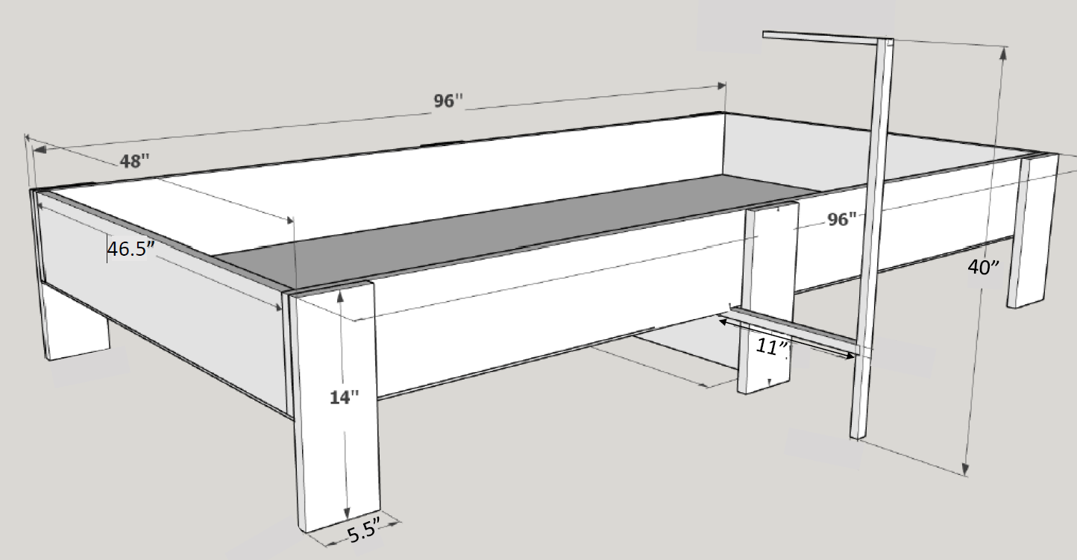

### Stabilizing Joint

